CRM APPLICATION FOR WHOLESALE RICE MILL

# Overview

The Rice Mill CRM Application is a comprehensive solution designed to streamline and simplify how much rice per day,how many were sold that rice and which type of rice all reports send to owners daily wise. It leverages the power of customer relationship management (CRM) to enhance customer experiences, optimize store operations, and improve overall efficiency in the rice mill factory. This project aims to develop a user-friendly and feature-rich application that addresses the specific needs of a rice mill factory.

# Features and Functionality

Reporting and Dashboards

* Daily Sales and Production Reports: Generates detailed reports on how much rice is produced & sold each day.
* Revenue Reports: Provides insights into daily revenue generated.
* Customer Analytics: Tracks popular rice types and most frequent buyers.
* Resource Allocation: Helps owners understand data for better resource allocation and future planning.

Rollup Summary Field

* Purpose: Summarizes data from a child object to a parent object that shares a master-detail relationship.
* Functions: Can use COUNT, SUM, MIN, and MAX functions.

Cross-Object Formula Field

* Purpose: References fields from another object in Salesforce.
* Function: Calculates the total amount payable by multiplying the number of rice units taken by the price per kg.

Validation Rules

* Purpose: Ensures data integrity by validating user inputs.
* Is Blank Formula: Verifies if a field is blank and displays an error message if the rule returns a value of "True".

Permission Sets

* Organization Wide Defaults (OWD): Defines the baseline level of access for the most restricted user.
* Roles and Access:
  + Owner: Can view records of employers and workers.
  + Employer: Can view records of workers.

# Milestone 1 - Salesforce

Introduction

Are you new to Salesforce? Not sure exactly what it is, or how to use it? Don’t know where you should start on your learning journey? If you’ve answered yes to any of these questions, then you’re in the right place. This module is for you.

Welcome to Salesforce! Salesforce is game-changing technology, with a host of productivity-boosting features, that will help you sell smarter and faster. As you work toward your badge for this module, we’ll take you through these features and answer the question, “What is Salesforce, anyway?”.

What Is Salesforce?

Salesforce is your customer success platform, designed to help you sell, service, market, analyze, and connect with your customers. Salesforce has everything you need to run your business from anywhere. Using standard products and features, you can manage relationships with prospects and customers, collaborate and engage with employees and partners, and store your data securely in the cloud.

So what does that really mean? Well, before Salesforce, your contacts, emails, follow-up tasks, and prospective deals might have been organized something like this:

[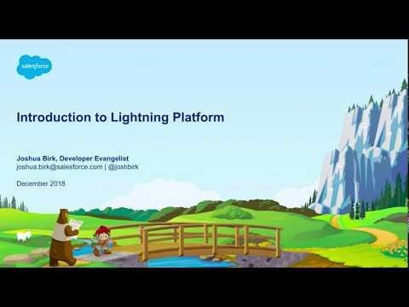](https://youtu.be/r9EX3lGde5k)

(Click the image to watch the video)

# Activity 1: Creating a Developer Account

To start using Salesforce, the first step is to create a developer org. Follow the steps below to create your Salesforce Developer Account:

Go to the Signup Page

* Navigate to the Salesforce Developer Signup page: [Salesforce Developer Signup](https://developer.salesforce.com/signup)

Fill Out the Signup Form

* First Name : VENKATA MADHURI
* Last Name : GUNTI
* Email : [21131a4211@gvpce.ac.in](mailto:21131a4211@gvpce.ac.in)
* Role : Developer
* Company : Gayatri Vidya Parishad
* Country : India
* Postal Code : 523105
* Username : [madhuri@gvpce.com](mailto:madhuri@gvpce.com)

Submit the Form

* After filling in the details, click on the "Sign me up" button.

You have successfully created a Salesforce Developer Account. You will receive a confirmation email with further instructions to complete the setup.

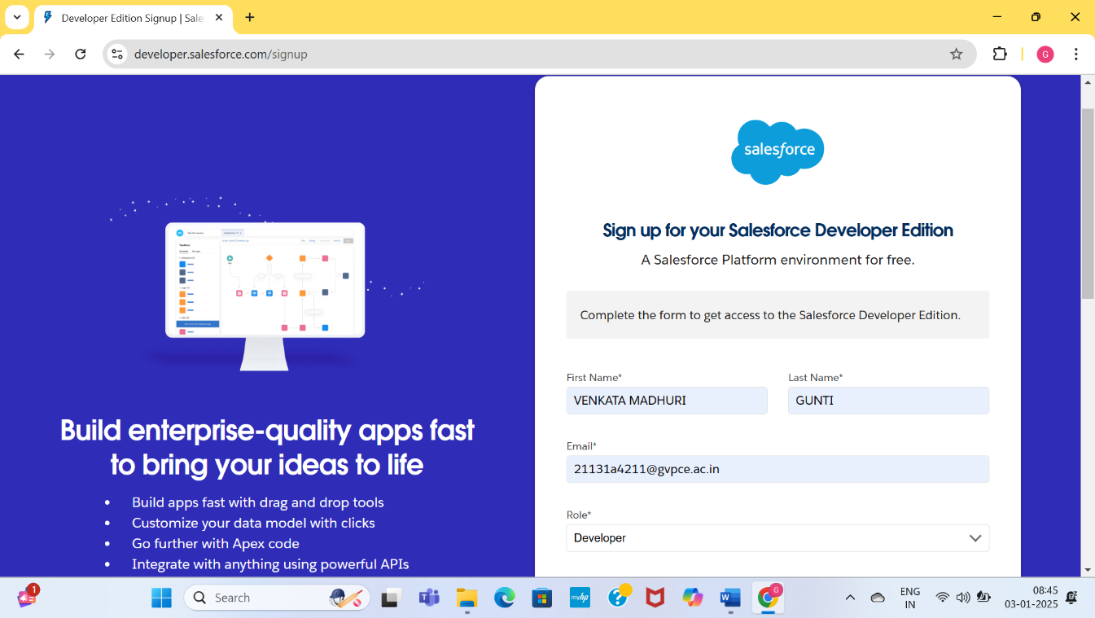

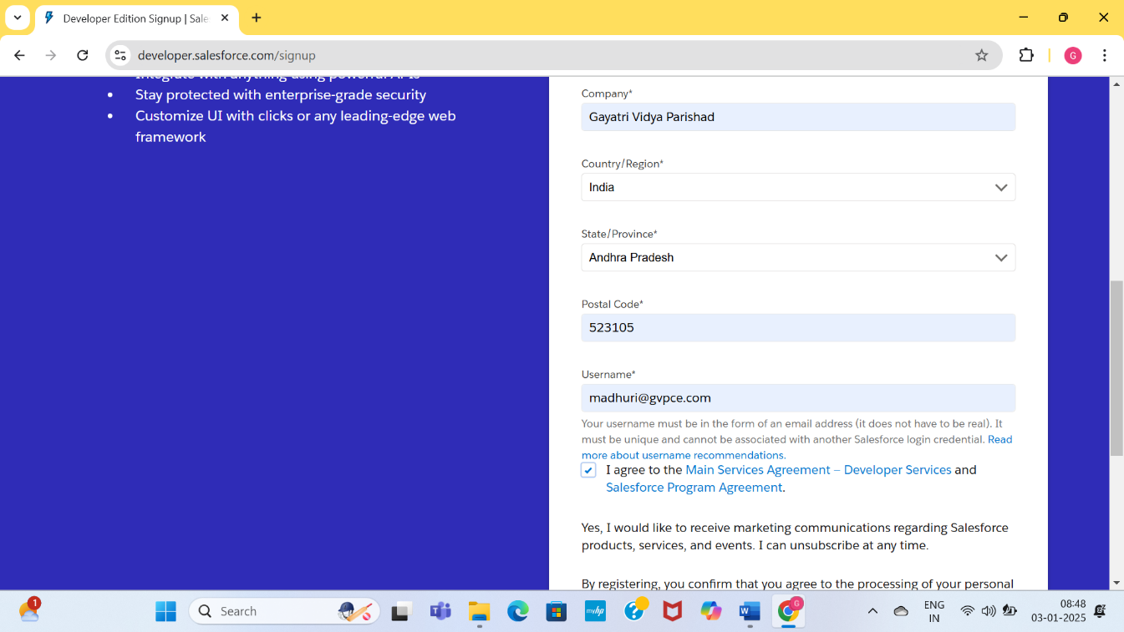

# Activity 2: Account Activation

After creating your Salesforce Developer Account, you need to activate it. Follow these steps to activate your account:

Check Your Email

* Go to the inbox of the email address you used while signing up. The verification email may take 5-10 minutes to arrive.

Verify Your Account

* Open the email from Salesforce and click on the "Verify Account" link.
* On the verification page, create a password for your account.
* Answer a security question for account recovery.
* Click on "Change Password".

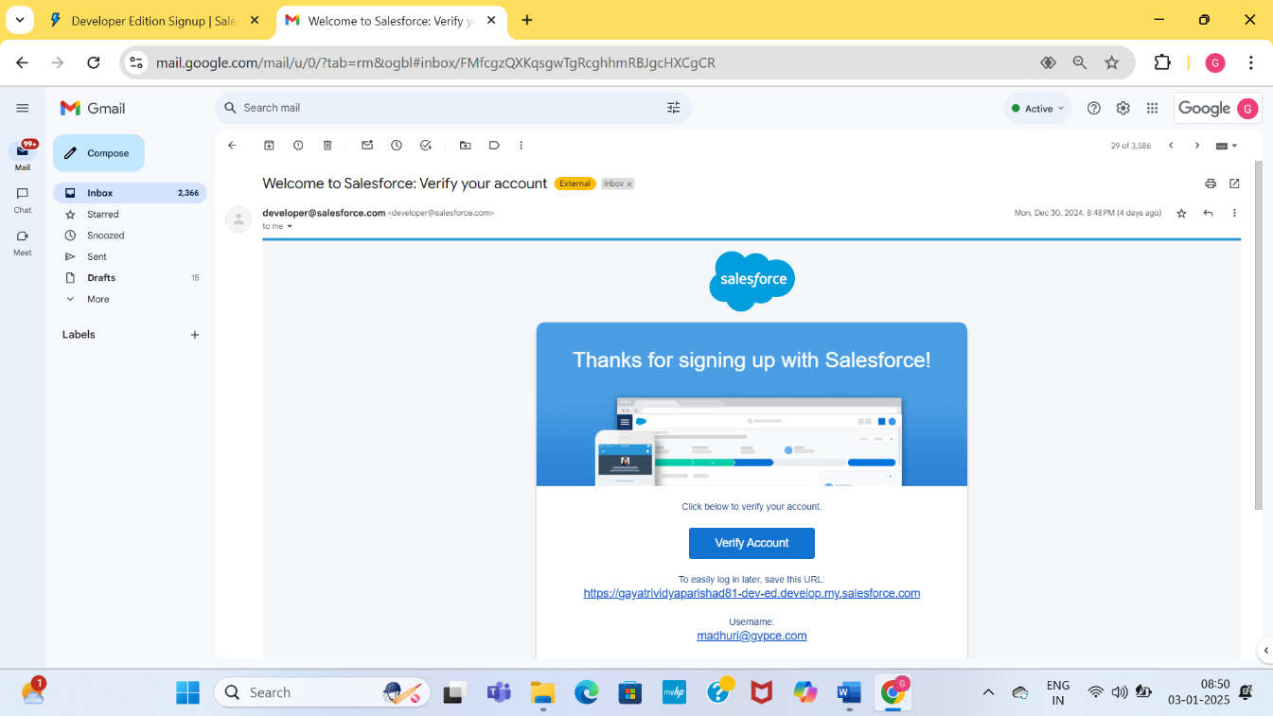

.

# Milestone 2 - Object

What Is an Object?

Salesforce objects are database tables that permit you to store data that is specific to an organization.

Types of Salesforce Objects

Salesforce objects are of two types:

* Standard Objects: Standard objects are provided by salesforce.com such as users, contracts, reports, dashboards, etc.
* Custom Objects: Custom objects are created by users. They supply information that is unique and essential to their organization. They are the heart of any application and provide a structure for sharing data.

To Navigate to Setup Page:

* + Click on the gear icon
  + Click on Setup

To Create an Object:

* From the setup page, click on Object Manager
* Click on Create
* Click on Custom Object
* On the Custom Object defining page:
* Enter the Label Name and Plural Label Name
* Click on Allow Reports
* Click on Allow Search
* Click on Save

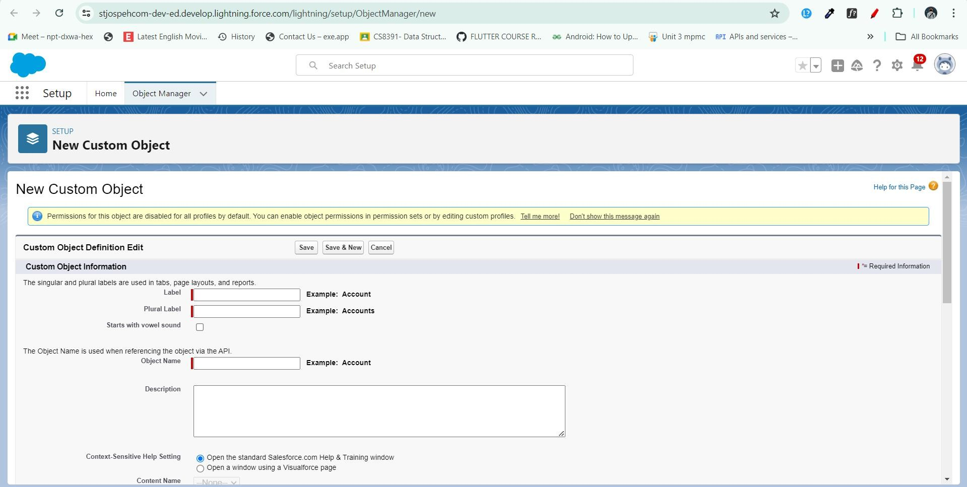

# Activity 1: Create Supplier Object

To create a Supplier object in Salesforce, follow these steps:

Navigate to Setup Page:

* Click on the gear icon.
* Click on Setup.

Create a Custom Object:

* From the setup page, click on Object Manager.
* Click on Create.
* Click on Custom Object.

Define the Custom Object:

* Enter the Label Name : Supplier.
* Enter the Plural Label Name : Suppliers.
* Enter the Record Name Label and Format:
* Record Name: Supplier Name
* Data Type: Text

Set Additional Options:

* Click on Allow Reports.
* Click on Track Field History.
* Click on Allow Search.

Save the Custom Object:

* Click on Save.+

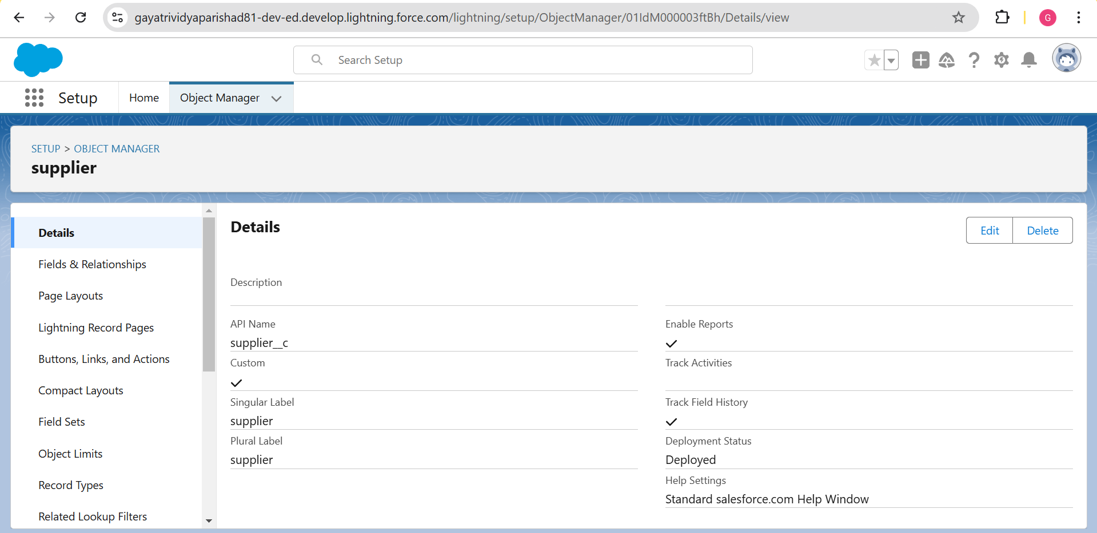

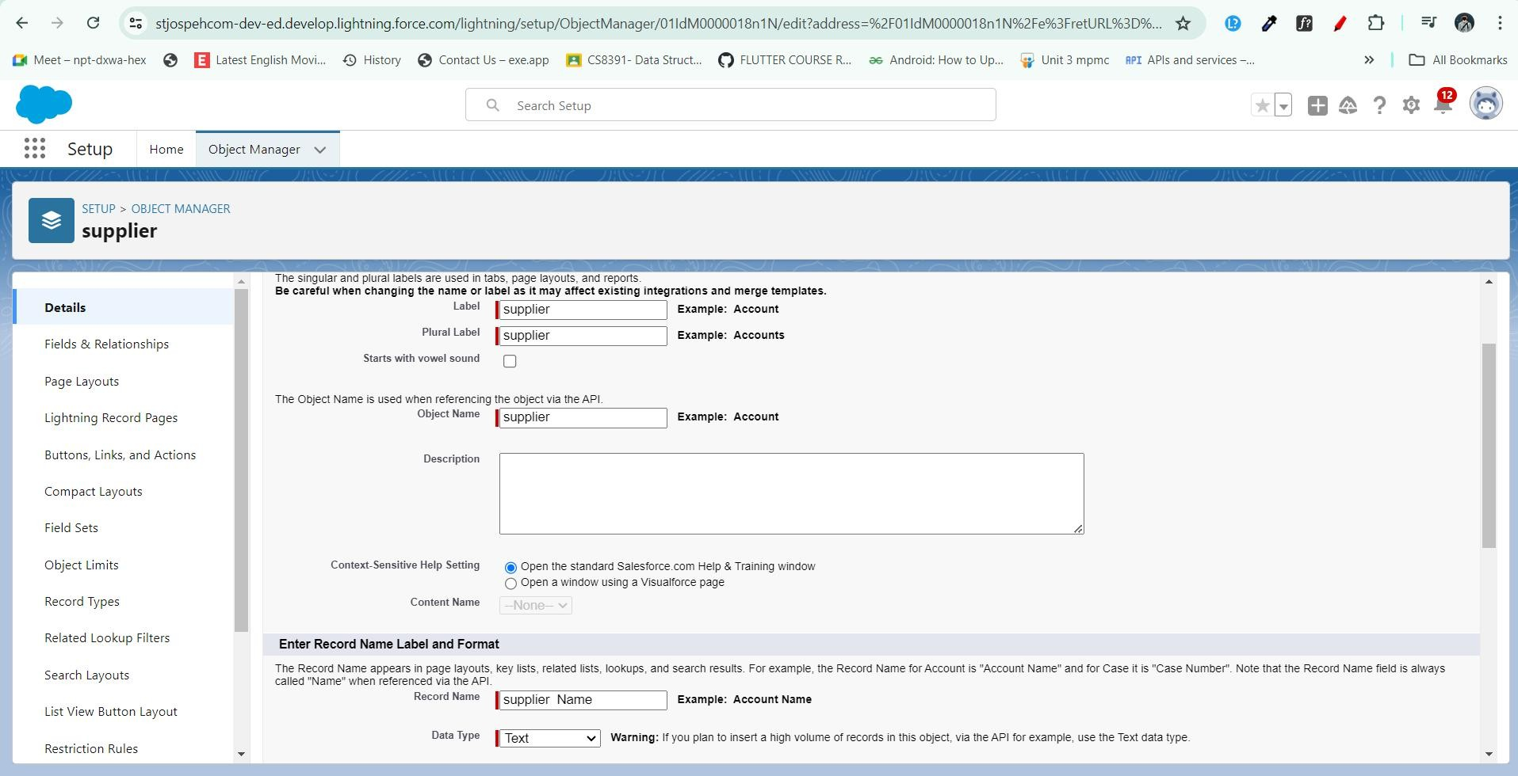

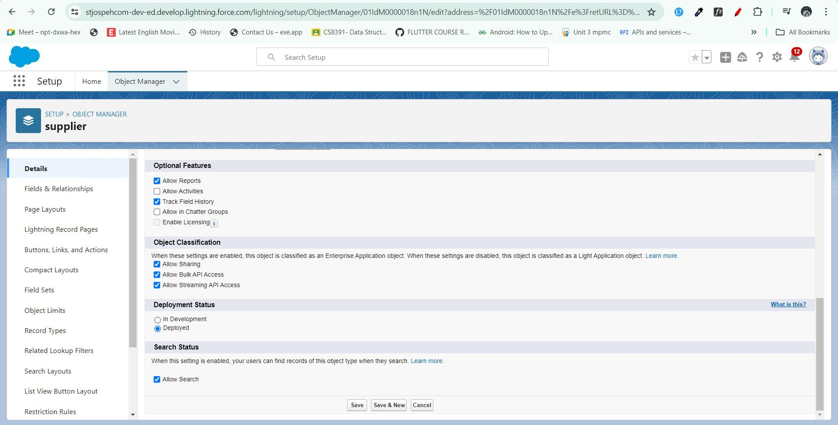

# Activity 2: Create Rice Mill Object

To create a Rice Mill object in Salesforce, follow these steps:

Navigate to Setup Page:

* Click on the gear icon.
* Click on Setup.

Create a Custom Object:

* From the setup page, click on **Object Manager**.
* Click on **Create**.
* Click on **Custom Object**.

Define the Custom Object:

* Enter the **Label Name**: Rice Mill.
* Enter the **Plural Label Name**: Rice Mills.
* Enter the **Record Name Label and Format**:
* **Record Name**: Leave it blank.
* **Data Type**: Auto Number
* **Display Format**: rice-{000}
* **Starting Number**: 1

Set Additional Options:

* Click on **Allow Reports**.
* Click on **Track Field History**.
* Click on **Allow Search**.

Save the Custom Object:

* Click on **Save**.

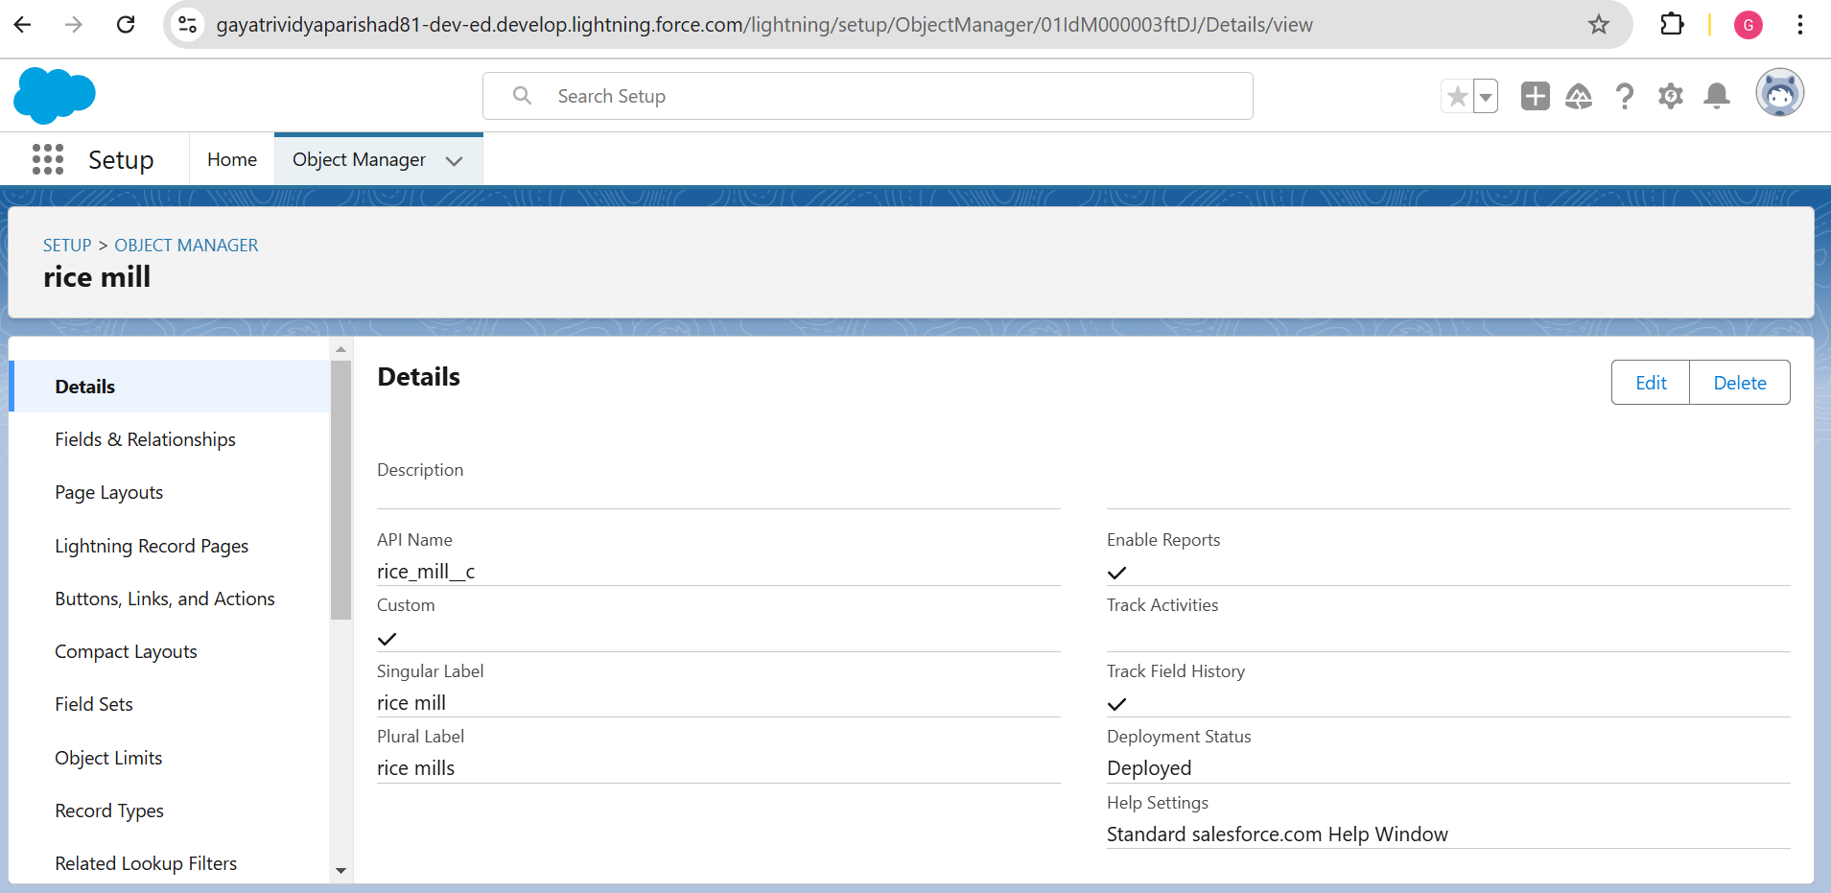

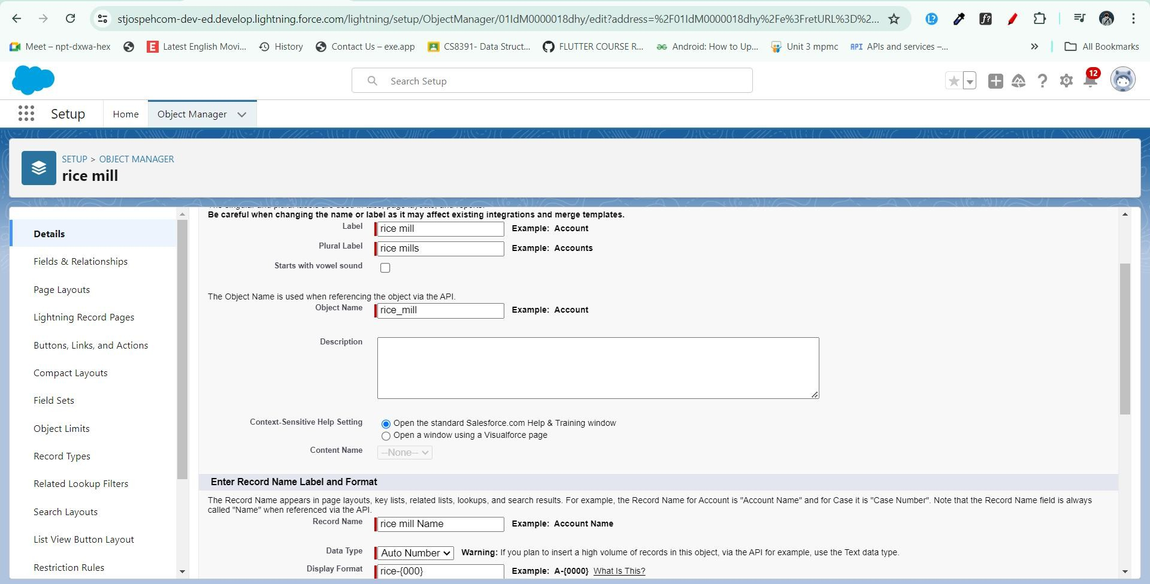

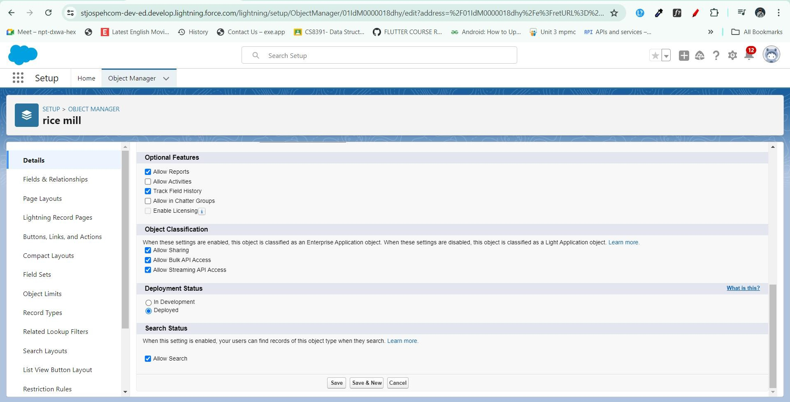

# Activity 3: Create Consumer Object

To create a Consumer object in Salesforce, follow the same steps as mentioned in Activity 2 for creating the Rice Mill object. Use the following details for the Consumer object:

Navigate to Setup Page:

* Click on the gear icon.
* Click on Setup.

Create a Custom Object:

* From the setup page, click on Object Manager.
* Click on Create.
* Click on Custom Object.

Define the Custom Object:

* Enter the Label Name: Consumer.
* Enter the Plural Label Name: Consumers.
* Enter the Record Name Label and Format:
* Record Name: Leave it blank.
* Data Type: Auto Number
* Display Format: consumers-{000}
* Starting Number: 1 Set Additional Options:
* Click on Allow Reports.
* Click on Track Field History.
* Click on Allow Search.

Save the Custom Object:

* Click on Save.

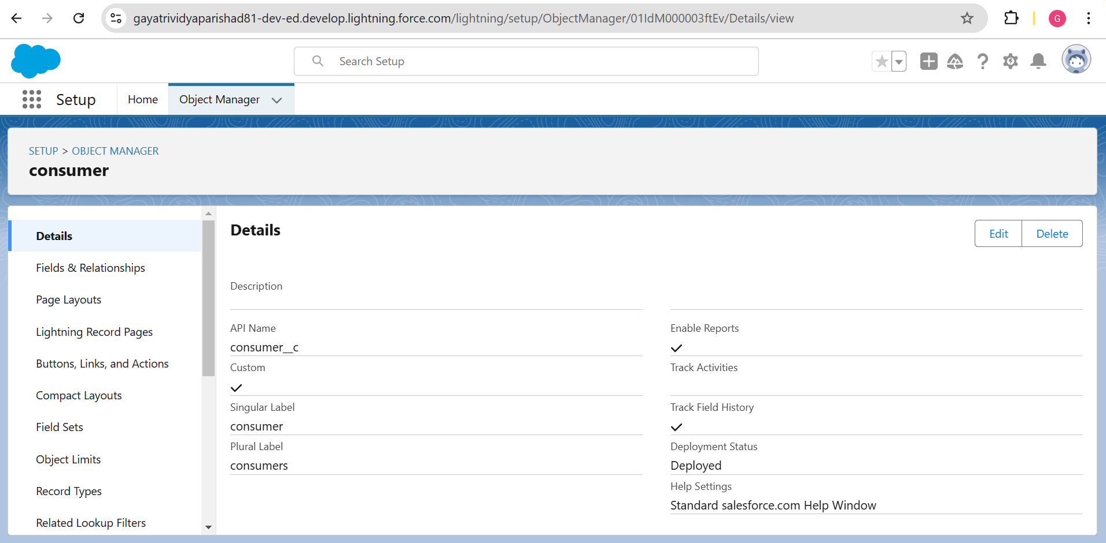

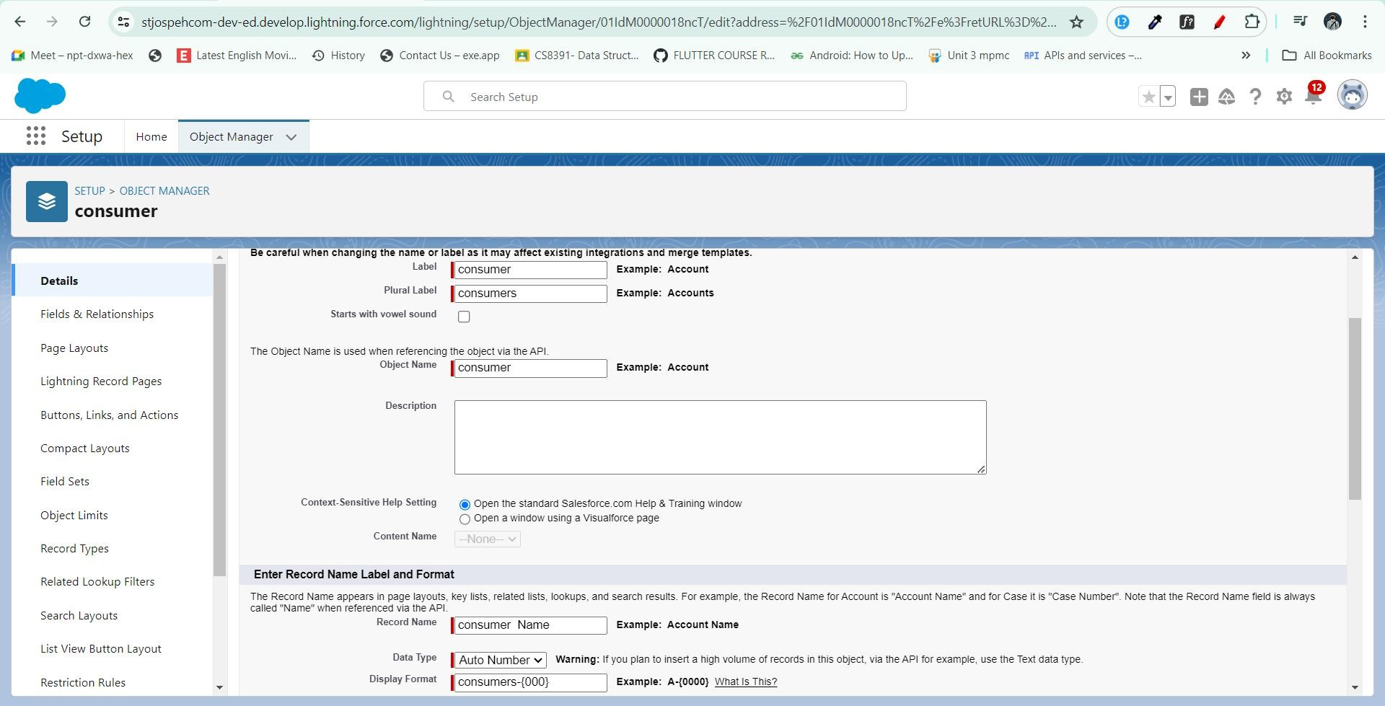

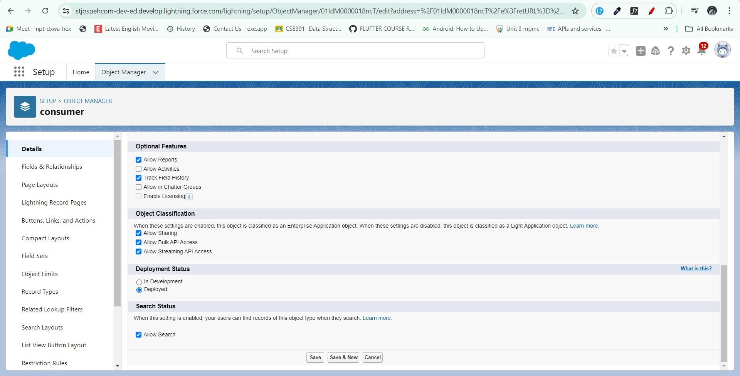

# Activity 4: Create Rice Details Object

To create a Rice Details object in Salesforce, follow these steps:

## Navigate to Setup Page:

* Click on the gear icon.
* Click on Setup.

## Create a Custom Object:

* From the setup page, click on Object Manager.
* Click on Create.
* Click on Custom Object.

## Define the Custom Object:

* Enter the Label Name: Rice Details.
* Enter the Plural Label Name: Rice Details.
* Enter the Record Name Label and Format:
* Record Name: Leave it blank.
* Data Type: Auto Number
* Display Format: rice-{000}
* Starting Number: 1

Set Additional Options:

* Click on Allow Reports.
* Click on Track Field History.
* Click on Allow Search.

Save the Custom Object:

* Click on Save.

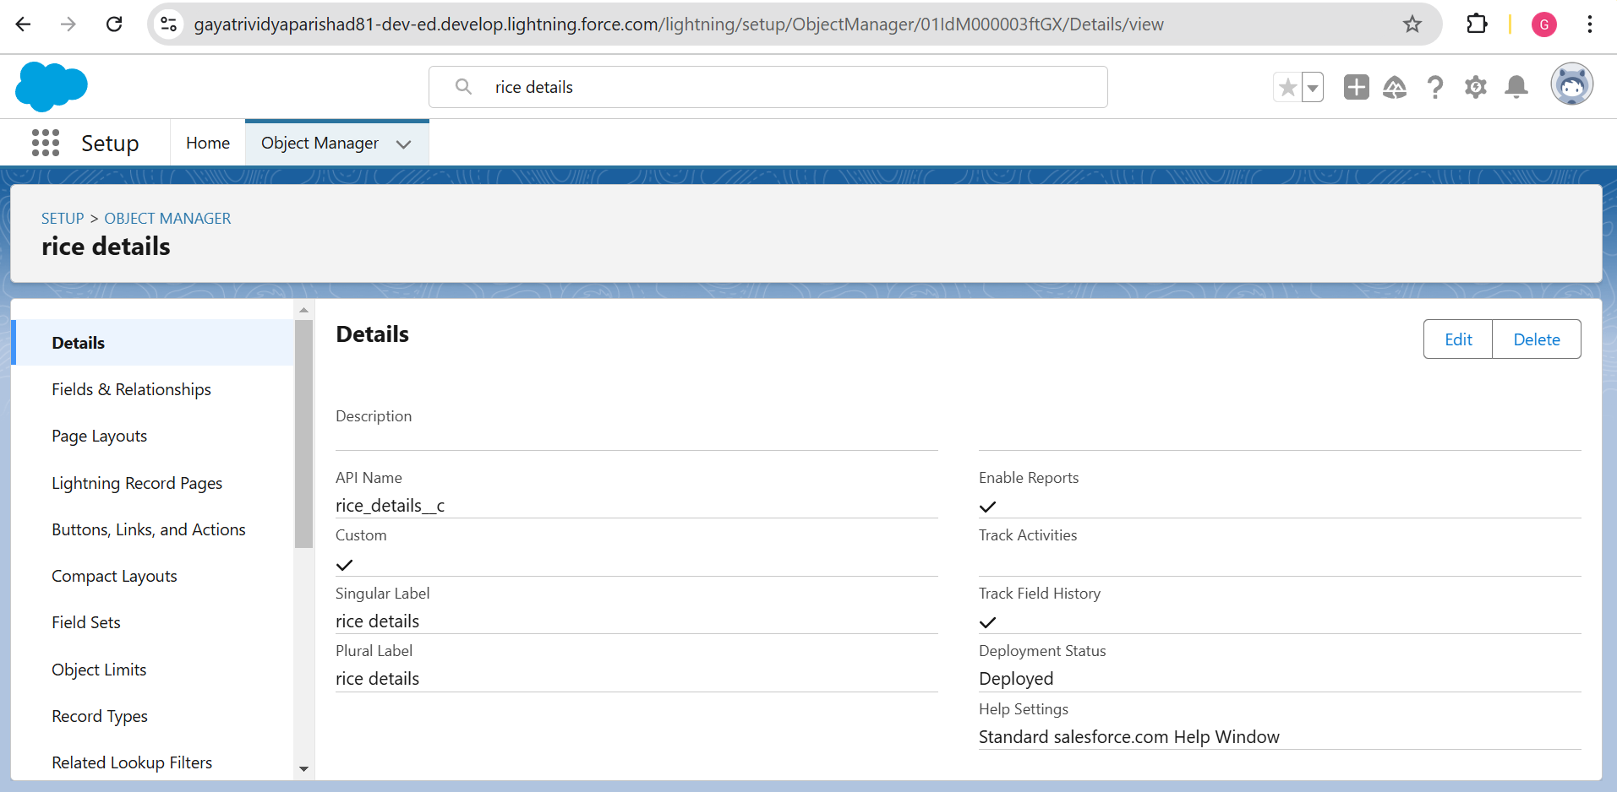

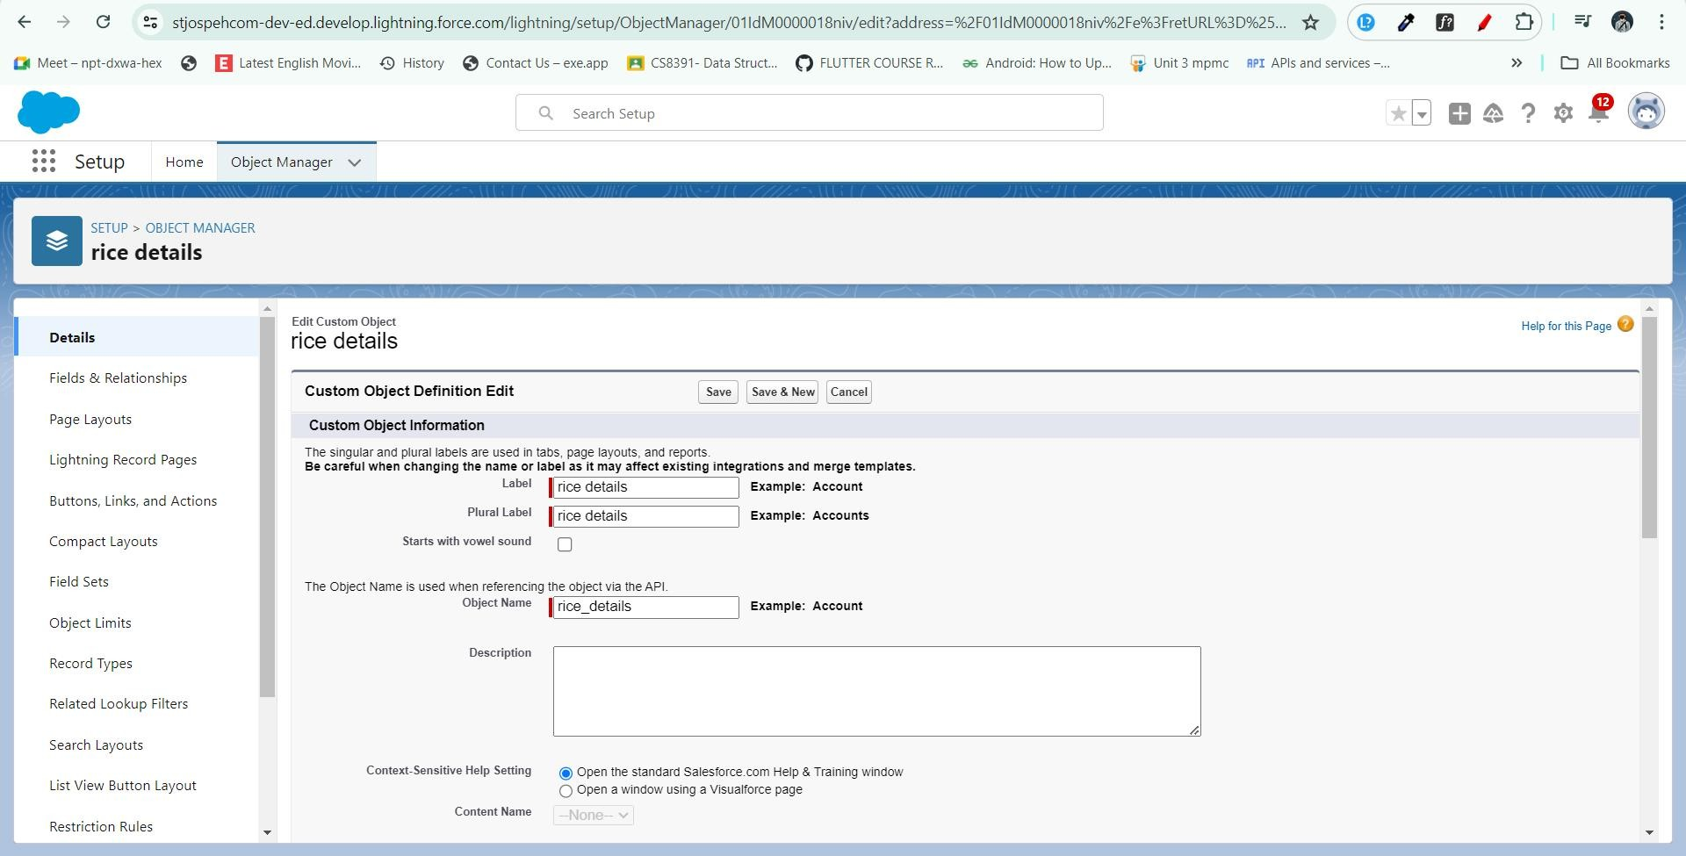

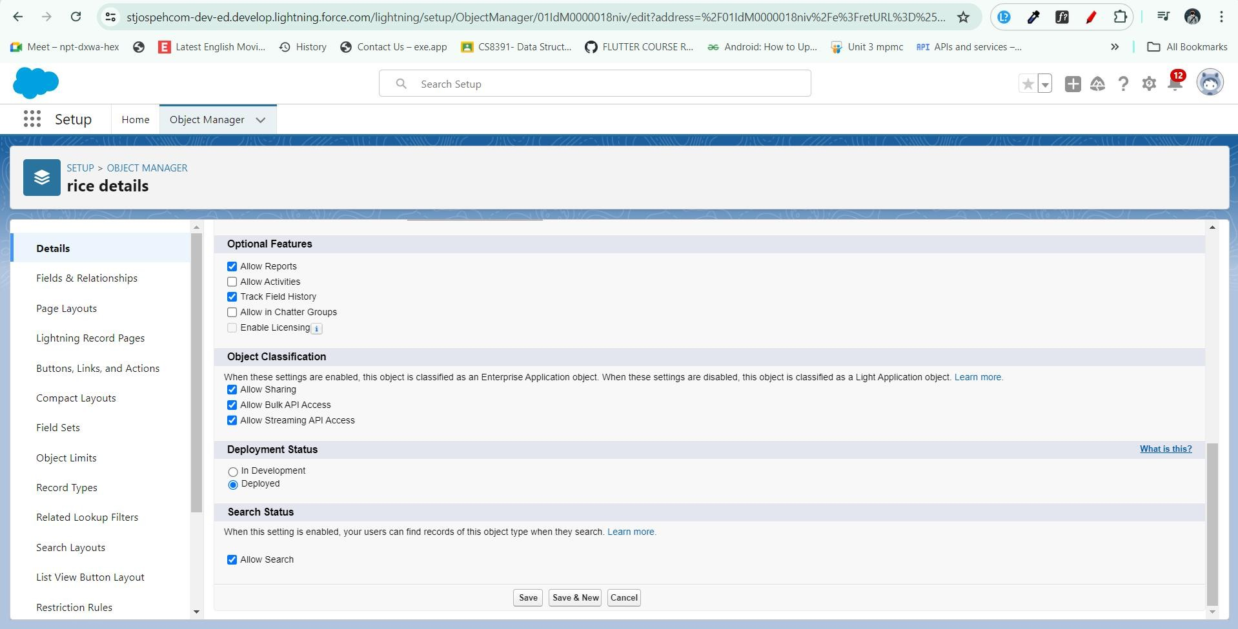

# Milestone 3 - Tabs

What is a Tab?

A tab is a user interface element used to build records for objects and view the records within those objects.

Custom Tabs: Custom object tabs are the user interface for custom applications that you build in salesforce.com. They look and behave like standard Salesforce tabs such as accounts, contacts, and opportunities.

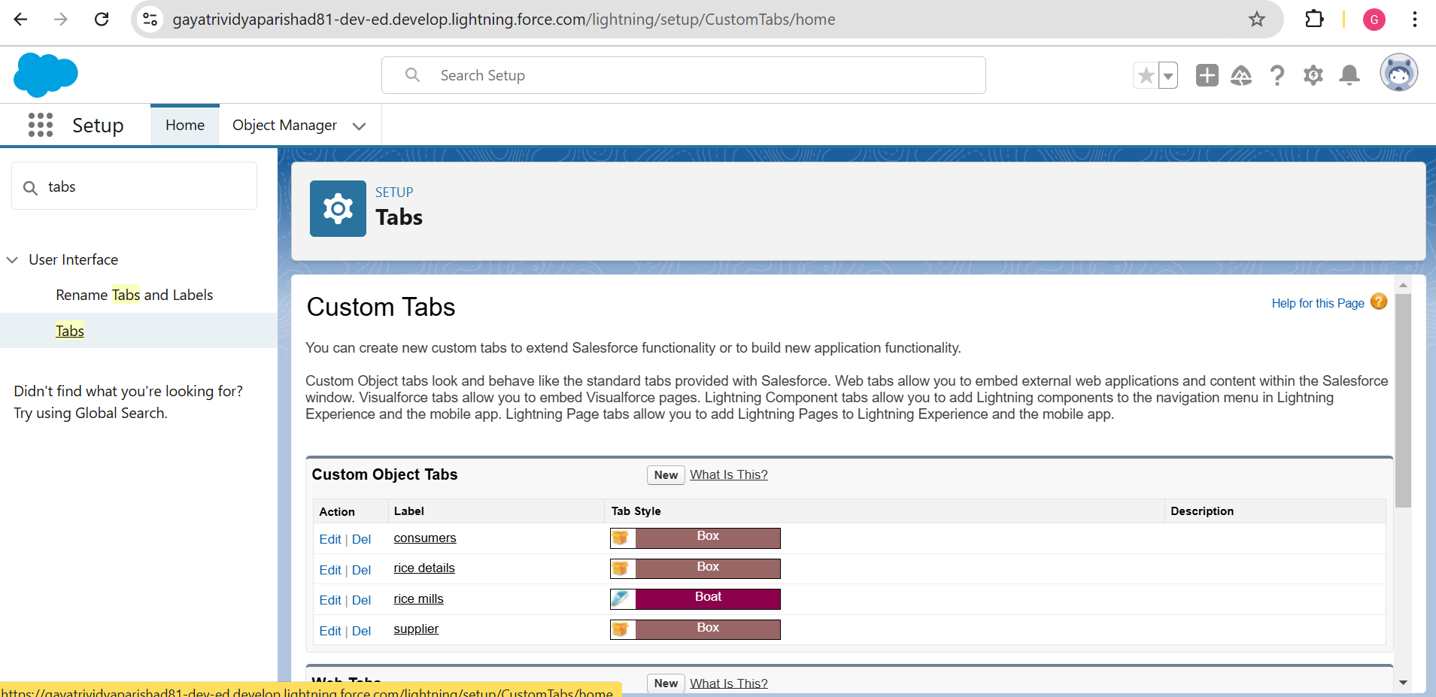

# Activity 1: Creating a Custom Tab (Supplier)

To create a Tab for the Supplier object, follow these steps:

Navigate to Setup Page:

* Go to the setup page.
* Type "Tabs" in the Quick Find bar.
* Click on Tabs.

Create a New Custom Object Tab:

* Click on New under the Custom Object Tabs section.

Select Object and Tab Style:

* Select the Supplier object.
* Choose the tab style.
* Click on Next.

Add to Profiles Page:

* Keep it as default.
* Click on Next.

Add to Custom App:

* Uncheck the Include Tab checkbox.

Append Tab to Users' Existing Personal Customizations:

* Ensure that the Append tab to users' existing personal customizations option is checked.

Save the Custom Tab:

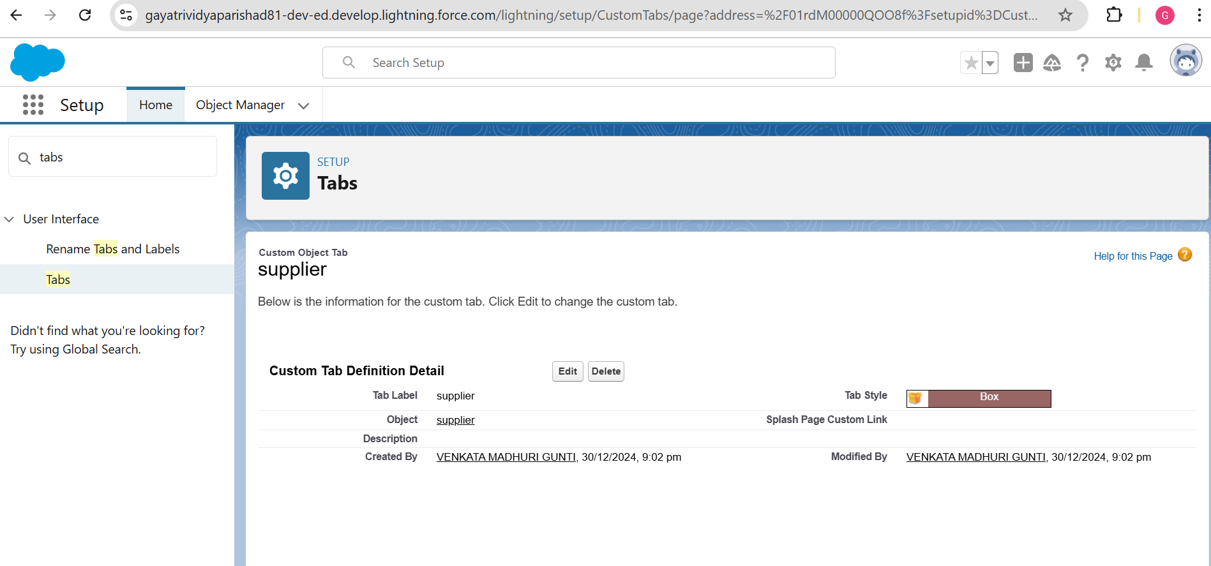

* Click on Save.

# Activity 2: Creating Remaining Tabs

To create tabs for the remaining objects (Rice Mill, Consumer, Rice Details), follow the same steps as mentioned in Activity 1.

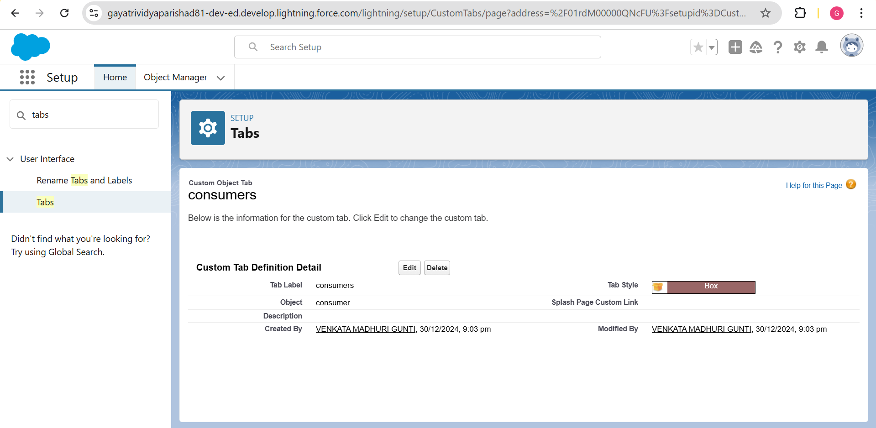

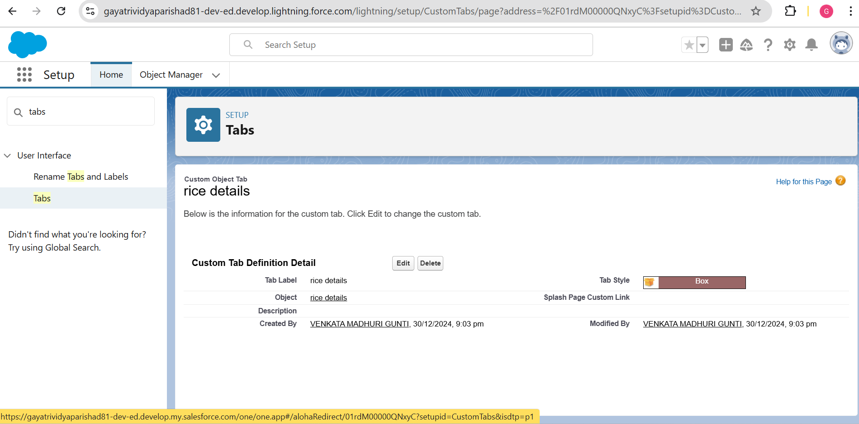

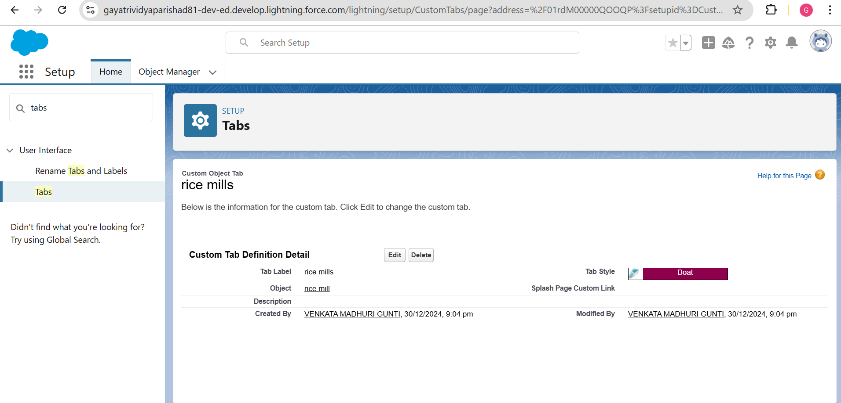

# Milestone 4 - The Lightning App

An app is a collection of items that work together to serve a particular function. In Lightning Experience, Lightning apps give your users access to sets of objects, tabs, and other items all in one convenient bundle in the navigation bar. Lightning apps let you brand your apps with a custom color and logo. You can even include a utility bar and Lightning page tabs in your Lightning app. Members of your organization can work more efficiently by easily switching between apps.

# Activity 1: Create a Lightning App

To create a Lightning app page, follow these steps:

Navigate to App Manager:

* Go to the setup page.
* Search for “App Manager” in the Quick Find bar.
* Select “App Manager”.
* Click on New Lightning App.

Fill in App Details:

* Enter the app name as MY RICE.
* Click Next.

App Options Page:

* Keep the settings as default.
* Click Next.

Utility Items Page:

* Keep the settings as default.
* Click Next.

Upload a Photo:

* Upload a photo that is related to your app.

Add Navigation Items:

* Select the items (Supplier, Rice Mill, Consumer, Rice Details) from the search bar.
* Move the selected items using the arrow button.
* Click Next.

Add User Profiles:

* Search for profiles (System Administrator) in the search bar.
* Click on the arrow button to add the profile.
* Click Save & Finish.

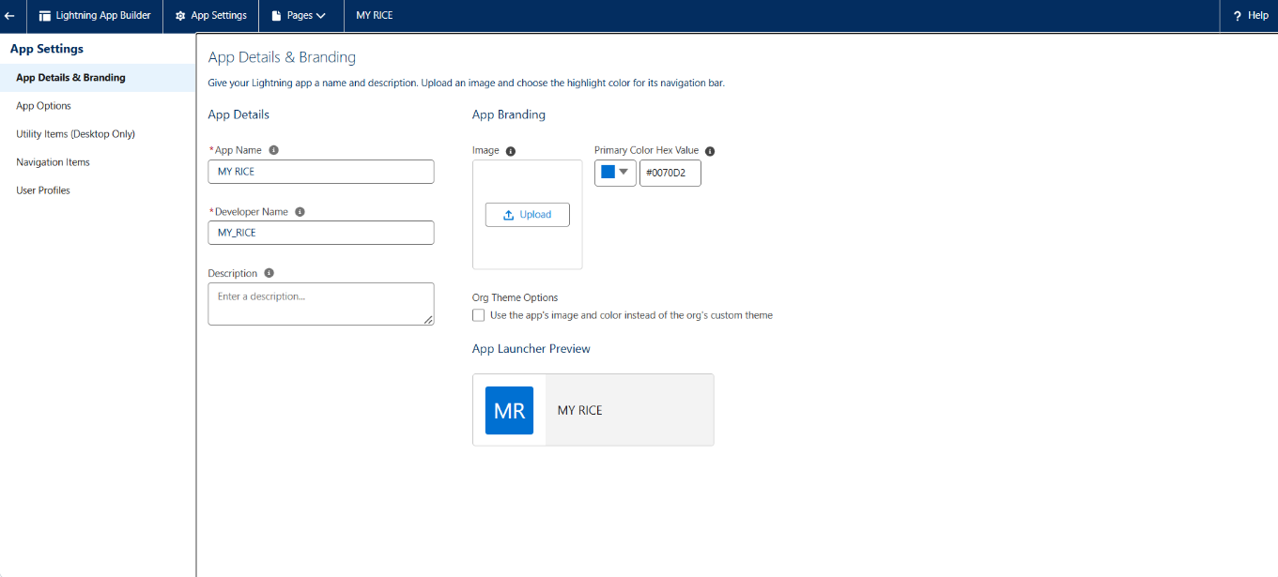

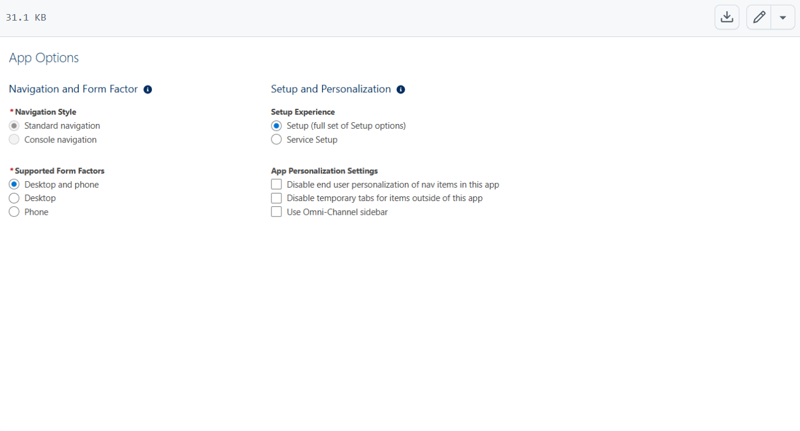

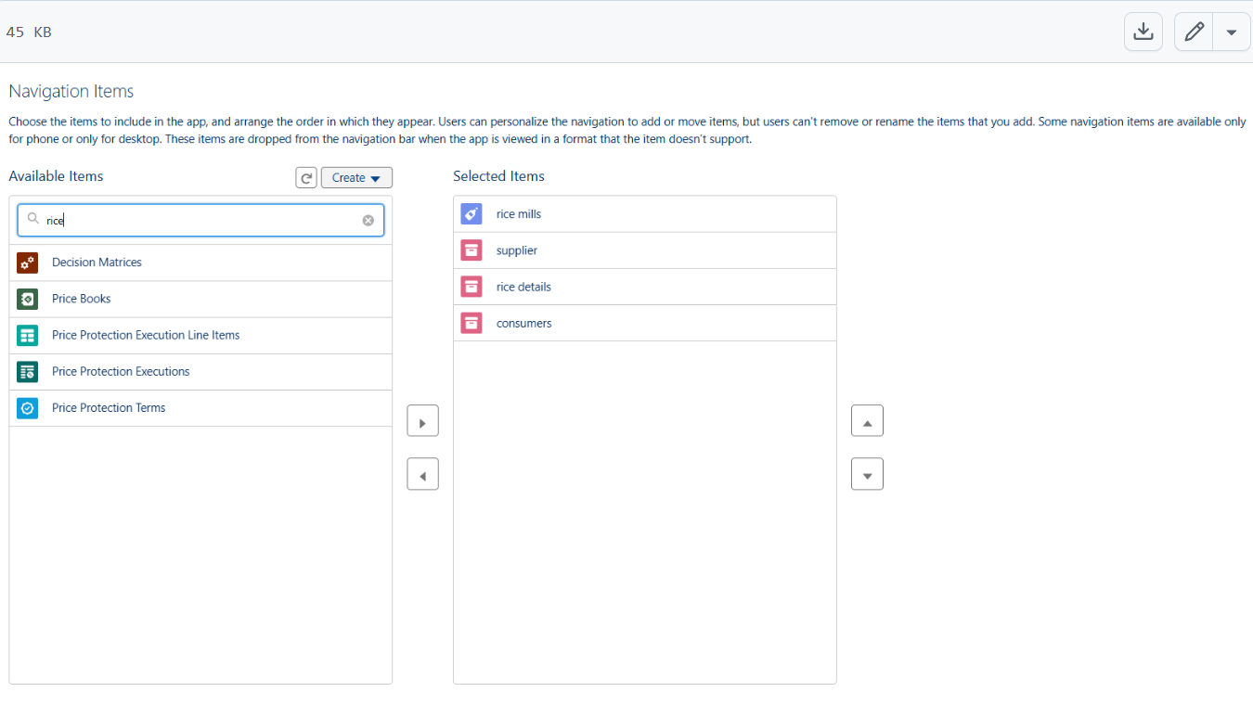

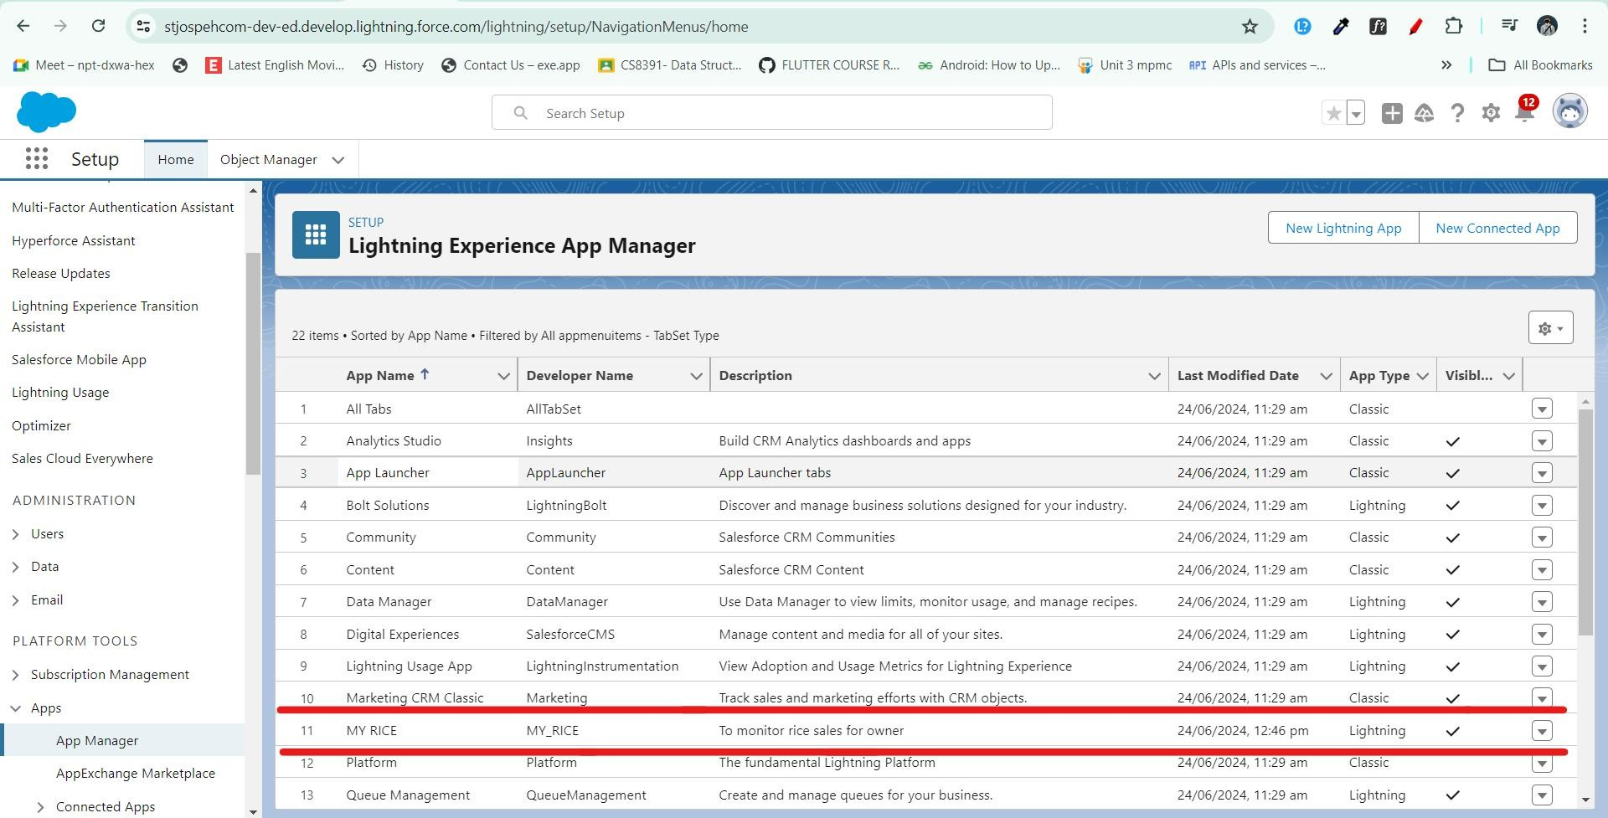

# Milestone 5: Fields

When we talk about Salesforce, fields represent the data stored in the columns of a relational database. They can hold any valuable information that you require for a specific object. The overall searching, deletion, and editing of the records become simpler and quicker with fields.

Types of Fields

1. Standard Fields
2. Custom Fields

Standard Fields

As the name suggests, Standard Fields are the predefined fields in Salesforce that perform a standard task. The main point is that you can’t simply delete a Standard Field unless it is a non-required standard field. Otherwise, users have the option to delete them freely at any point from the application. Some common fields you will find in every Salesforce application include:

* + Created By
  + Owner
  + Last Modified
  + Field Made During Object Creation

Custom Fields

On the other side of the coin, Custom Fields are highly flexible, and users can change them according to their requirements. Each organization or company can use them if necessary. It means you do not always need to include them in the records, unlike Standard Fields. Hence, the final decision depends on the user, who can add or remove Custom Fields as needed.

# Activity 1: Creating the Number Field in Rice Details Object

To create a number field in the Rice Details object, follow these steps:

Navigate to Object Manager:

* Go to the setup page.
* Click on Object Manager.

Edit the Rice Details Object:

* From the dropdown, click Edit for the Rice Details object.

Create a New Field:

* Click on Fields & Relationships.
* Click on New.

Select Data Type:

* Select Number as the data type.
* Click Next.

Define Field Properties:

* Enter the Field Label as Rice Distributed.
* Set the length to 5.

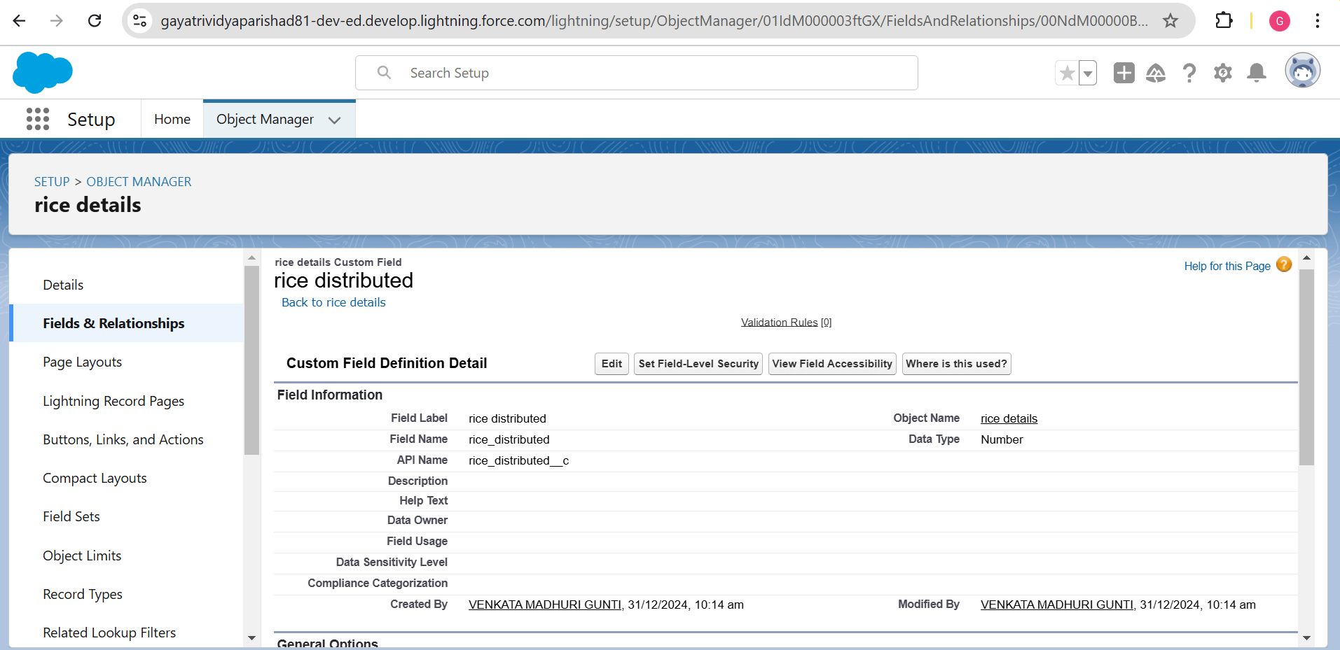

# Activity 2: Creating Junction Object

A Junction Object is a custom object that serves as a bridge between two related objects in a many-to-many relationship. It allows you to create a relationship between records of two different objects by creating a many-to- many relationship model.

Creating Junction Object: Rice Details with Supplier & Rice Mill To create a Junction Object:

Navigate to Object Manager:

* Go to the setup page.
* Click on Object Manager.
* From the dropdown, click Edit for the Rice Details object.

Create a New Field:

* Click on Fields & Relationships.
* Click on New.

Select Data Type:

* Select Master-Detail Relationship as the data type.
* Click Next.

Relate to Supplier Object:

* Select the related object Supplier.
* Click Next.

Define Field Properties:

* Give the Field Label as Supplier Name.
* Click Next.
* Click Next again.
* Click Save & New.

Repeat Steps for Rice Mill Object:

* Follow the same steps from 1 to 3.
* Select the related object Rice Mill.
* Click Next.

Define Field Properties for Rice Mill:

* Give the Field Label as Rice Mill 1 (one).
* Click Next.
* Click Next again.
* Click Save.

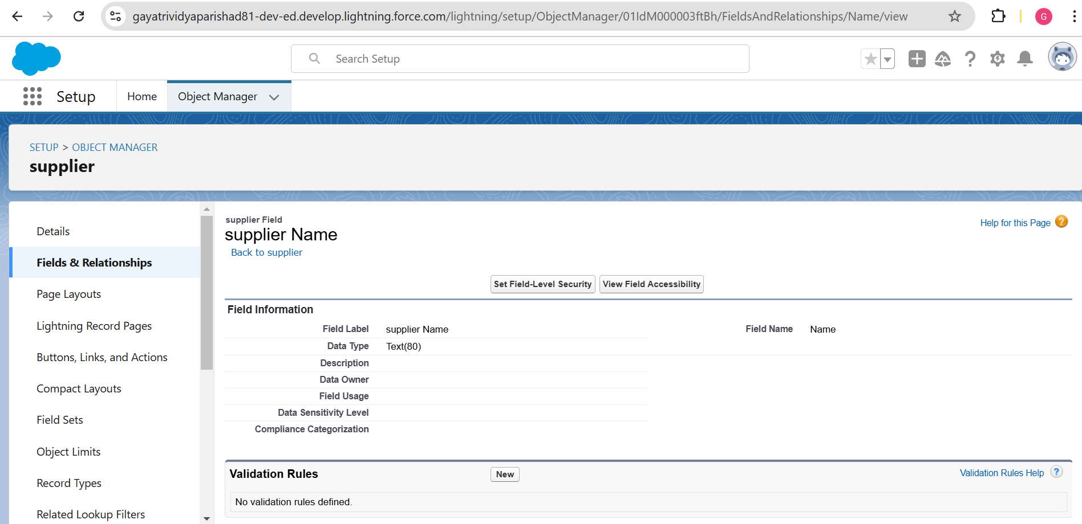

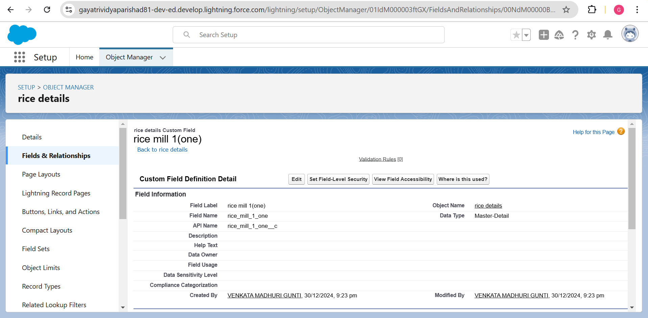

# Activity 3: Creating a Master-Detail Relationship

A master-detail relationship is a type of relationship between two objects where the master object controls certain behaviors and settings of the detail object. Here are a few use cases that demonstrate the use of master-detail relationships.

Creating Master-Detail Relationship between Consumer & Rice Mill Object To create a Master-Detail relationship:

Navigate to Object Manager:

* Go to the setup page.
* Click on Object Manager.
* From the dropdown, click Edit for the Consumer object.

Create a New Field:

* Click on Fields & Relationships.
* Click on New.

Select Data Type:

* Select Master-Detail Relationship as the data type.
* Click Next.

Relate to Rice Mill Object:

* Select the related object Rice Mill.
* Click Next.

Define Field Properties:

* Give the Field Label as Rice Mill Name.
* Click Next. , Click Next again.
* Click Save.

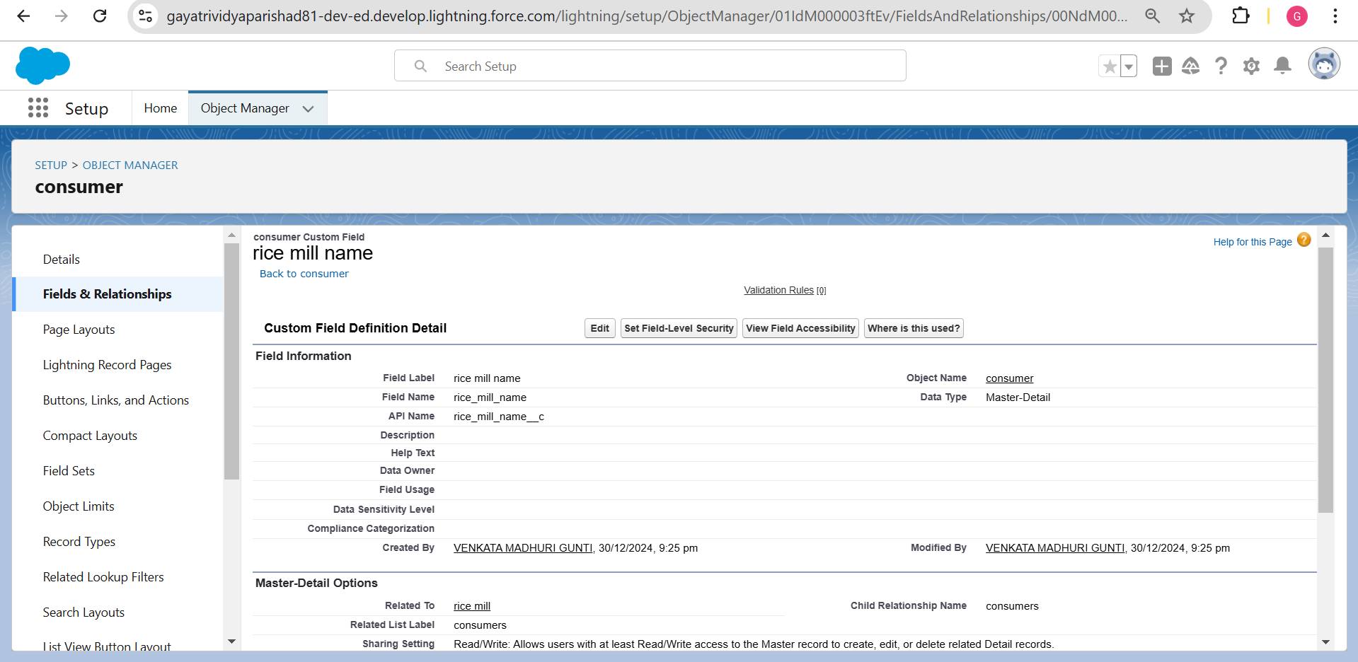

# Activity 4: Creating the Roll-up Summary

A roll-up summary field is a field that summarizes data from a child object to a parent object that shares a master- detail relationship. Roll-up summary fields can use the COUNT, SUM, MIN, and MAX functions. For example, you could use a roll-up summary field to display the total value (amount of rice supplied) from rice details on a related supplier.

Creating the Roll-up Summary Field on Supplier & Rice Mill Objects To create a Roll-up Summary field:

Navigate to Object Manager:

* Go to the setup page.
* Click on Object Manager.
* Type the object name Supplier in the search bar.
* Click on the object.

Create a New Field:

* Click on Fields & Relationships.
* Click on New.

Select Data Type:

* Select the data type as Roll-up Summary.
* Click Next.

Define Field Properties for Supplier:

* Give the Field Label as Sum of Rice Distributed. The Field Name will be auto-generated.
* Click Next.

Configure Roll-up Summary for Supplier:

* Select the summarized object as Rice Details.
* Select the roll-up type as SUM.
* Select the field to aggregate as Rice Distributed.
* Click Next. , Click Next again.
* Click Save.

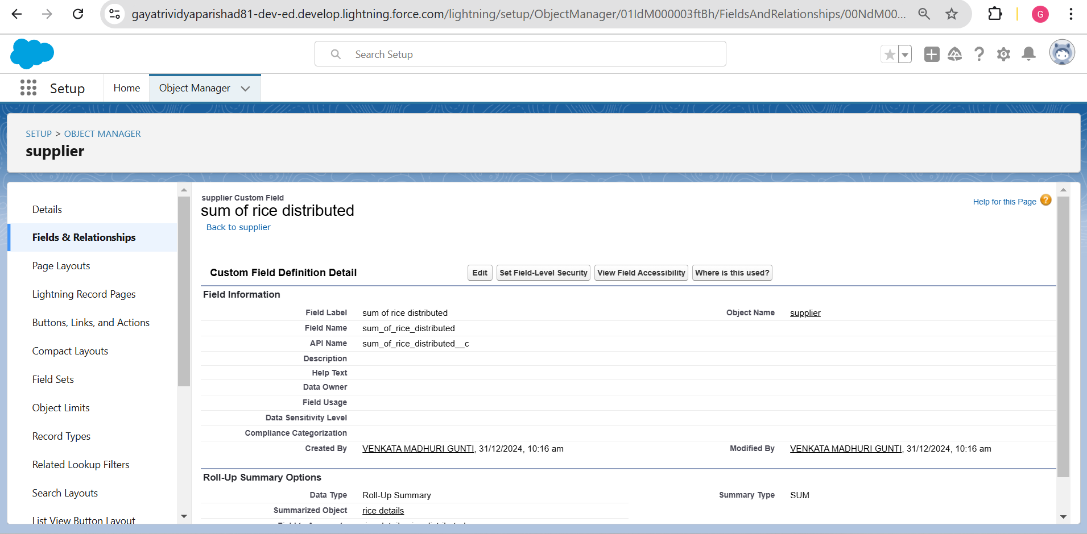

Repeat Steps for Rice Mill Object:

* Follow the same steps from 1 to 3 for the Rice Mill object.
* Give the Field Label as Rice Distributed to Shops. The Field Name will be auto-generated.
* Click Next.

Configure Roll-up Summary for Rice Mill:

* Select the summarized object as Rice Details.
* Select the roll-up type as SUM.
* Select the field to aggregate as Rice Distributed.
* Click Next. ,
* Click Next again.
* Click Save.

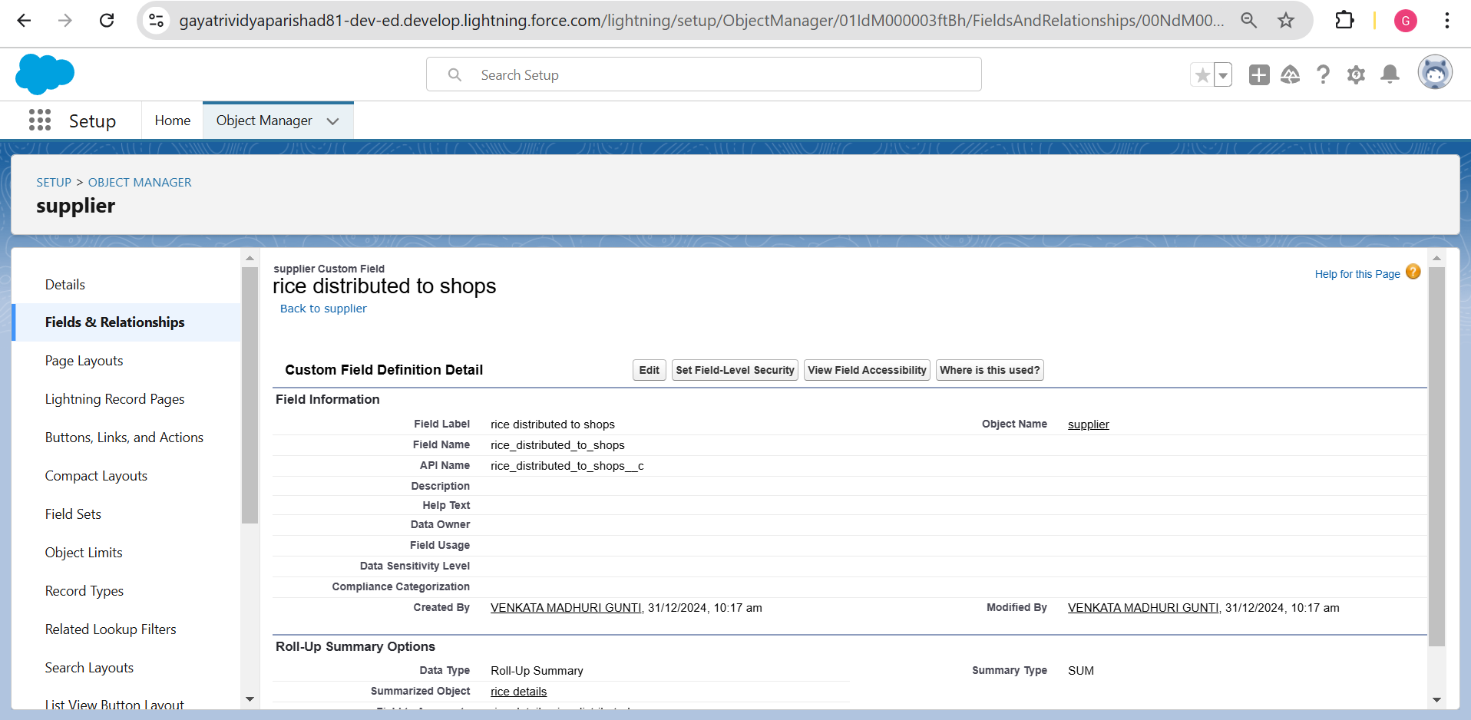

Additional Steps for Consumer Object Create the Field:

* Create the field Rice Taken by Shops in Kgs using the number datatype in the Consumer object.

Repeat Steps for Rice Mill Object:

* Follow the same steps from 1 to 3 for the Rice Mill object.
* Give the Field Label as Rice Taken. The Field Name will be auto-generated.
* Click Next.

Configure Roll-up Summary for Rice Mill (Consumer):

* Select the summarized object as Consumer.
* Select the roll-up type as SUM.
* Select the field to aggregate as Rice Taken in Shops.
* Click Next .
* Click Next again.
* Click Save.

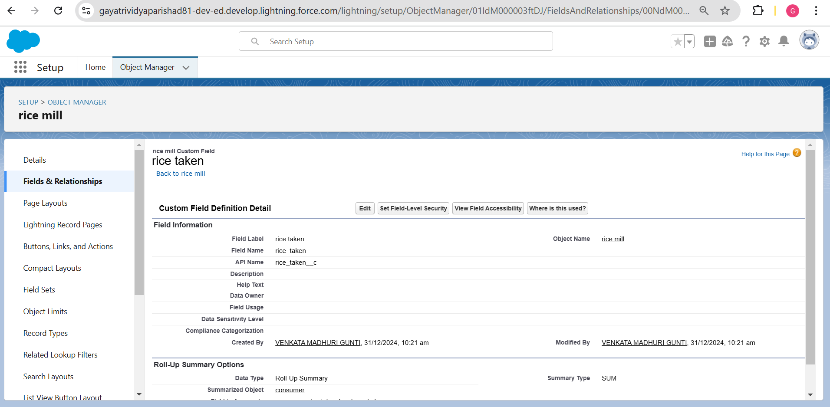

# Activity 5: Creating Fields in Objects

Creating the number field in the Rice Details object.

Navigate to Setup:

* Go to the setup page.
* Click on "Object Manager" from the top navigation menu.

Edit Rice Details Object:

* In Object Manager, find and select "Rice Details" from the list of objects.
* Click on "Fields & Relationships."

Create New Field:

* Click on the "New" button to create a new field.

Select Data Type:

* Choose "Number" as the data type for the field.
* Click "Next."

Define Field Properties:

* Enter "Supplier Name" as the Field Label.
* Set the length to "5" (assuming this refers to the precision or size of the number).
* Field Name will be automatically populated based on the label.

Proceed with Creation:

* Click "Next" to proceed through any additional screens.
* Review the field details and click "Save" to create the new field.

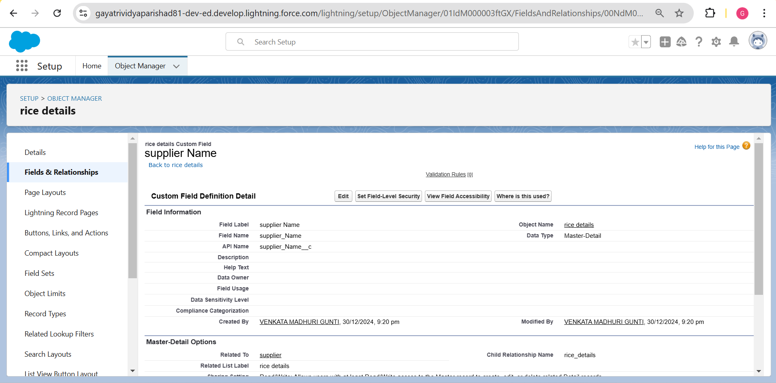

# Activity 6: Creating Fields in Rice Mill Objects

Navigate to Setup:

* Go to the setup page.
* Click on "Object Manager" from the top navigation menu.

Edit Rice Mills Object:

* In Object Manager, find and select "Rice Mills" from the list of objects.
* Click on "Fields & Relationships."

Create New Field:

* Click on the "New" button to create a new field.

Select Data Type:

* Choose "Number" as the data type for the field.
* Click "Next."
* Given the Field Label as "Rice Price/kg" and length as "5".

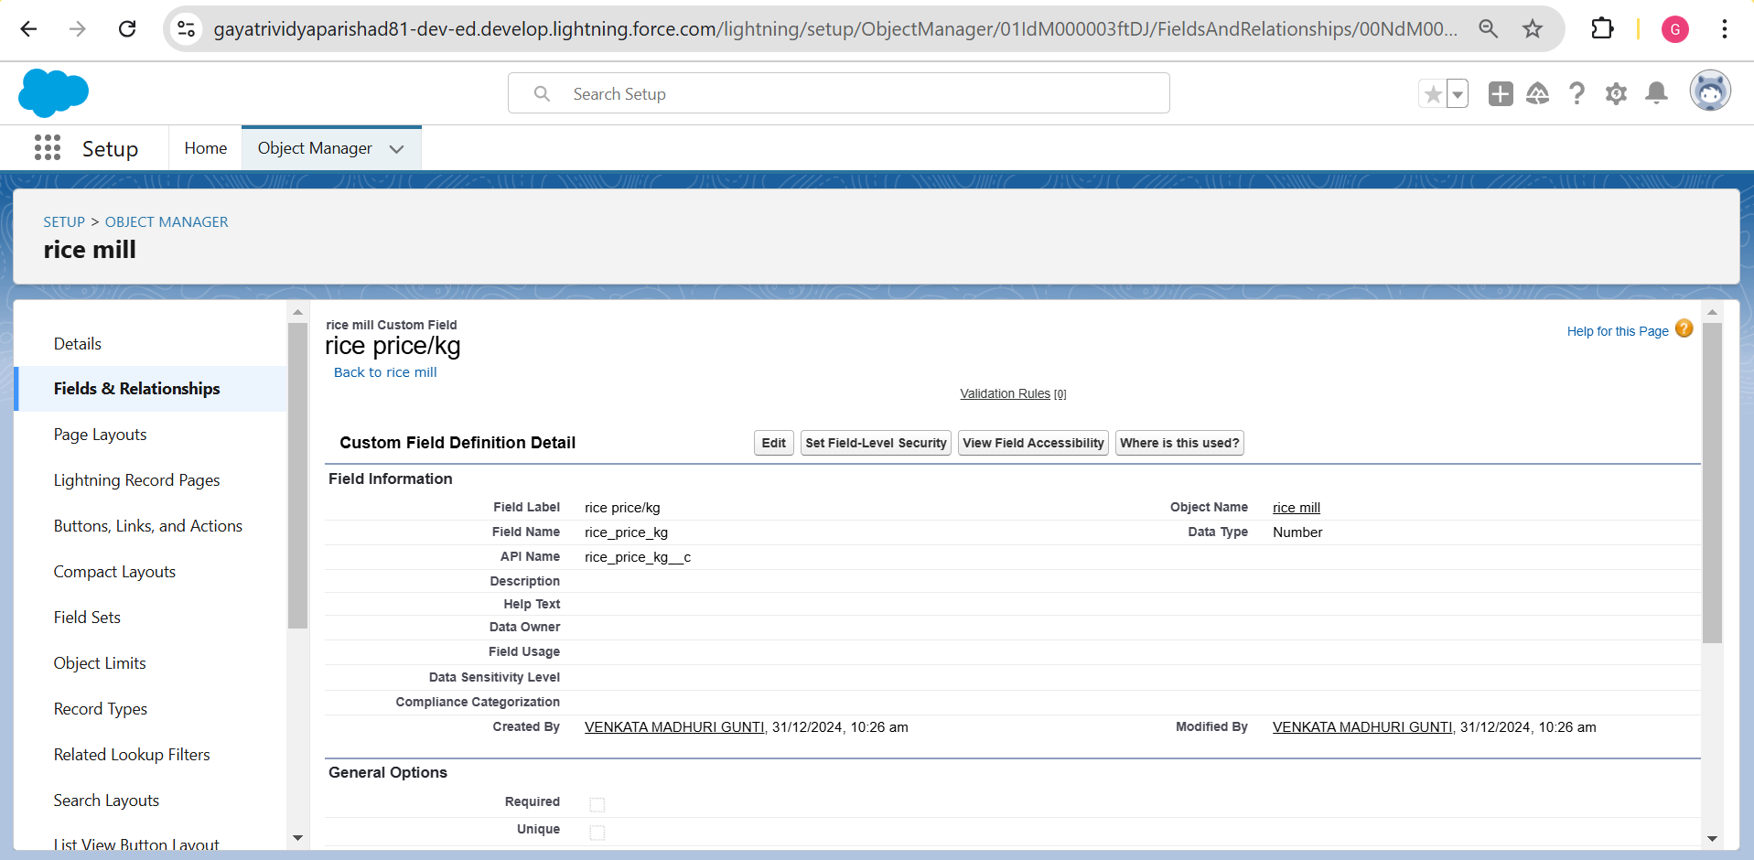

# Activity 7: Creating Fields in Consumer Objects

Navigate to Setup:

* Go to the setup page.
* Click on "Object Manager" from the top navigation menu.

Edit Consumer Object:

* In Object Manager, find and select "Consumer" from the list of objects.
* Click on "Fields & Relationships."

Create New Field For First Name:

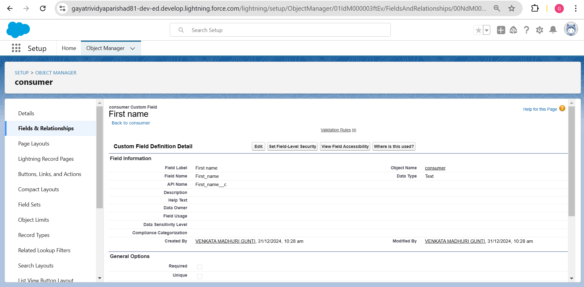

Create New Field For Last Name:

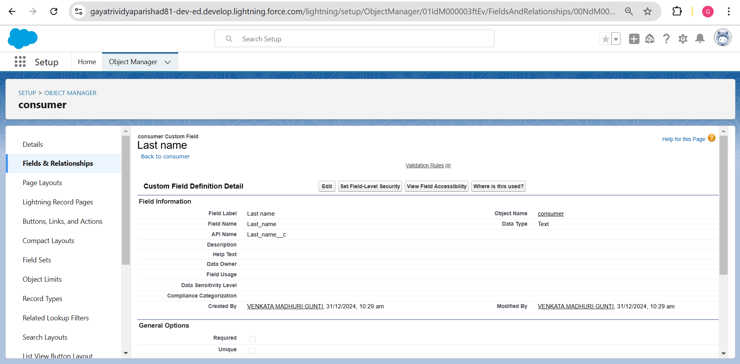

Create New Field For Email :

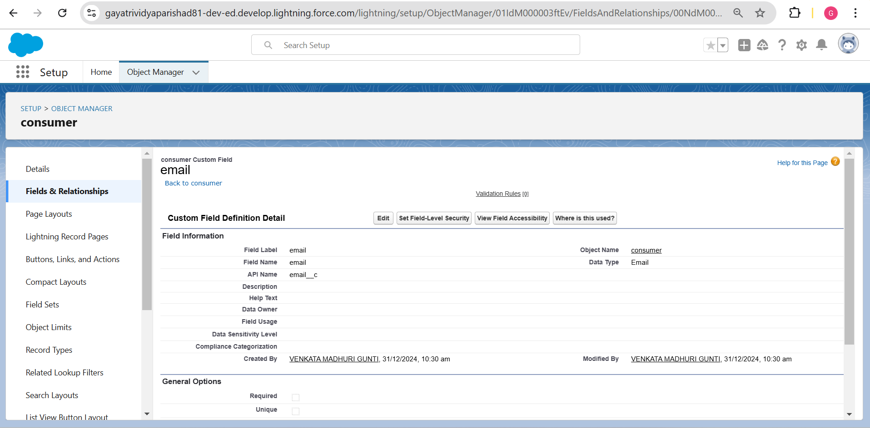

Create New Field For Rice Taken By Shops:

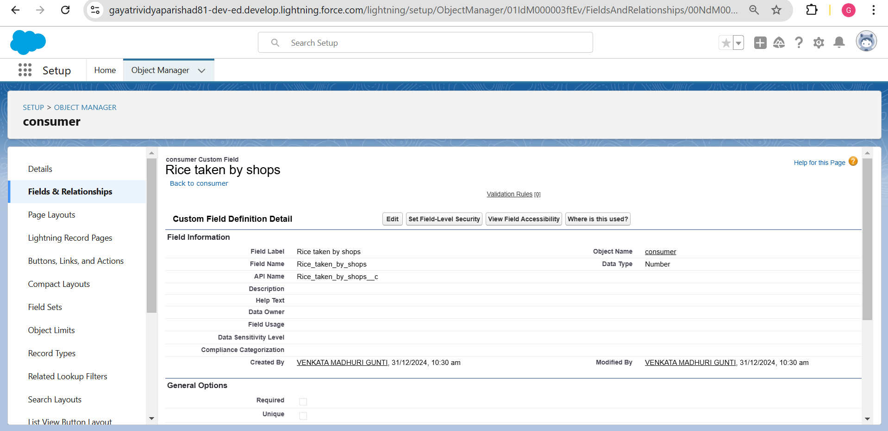

Create New Field For Rice Type:

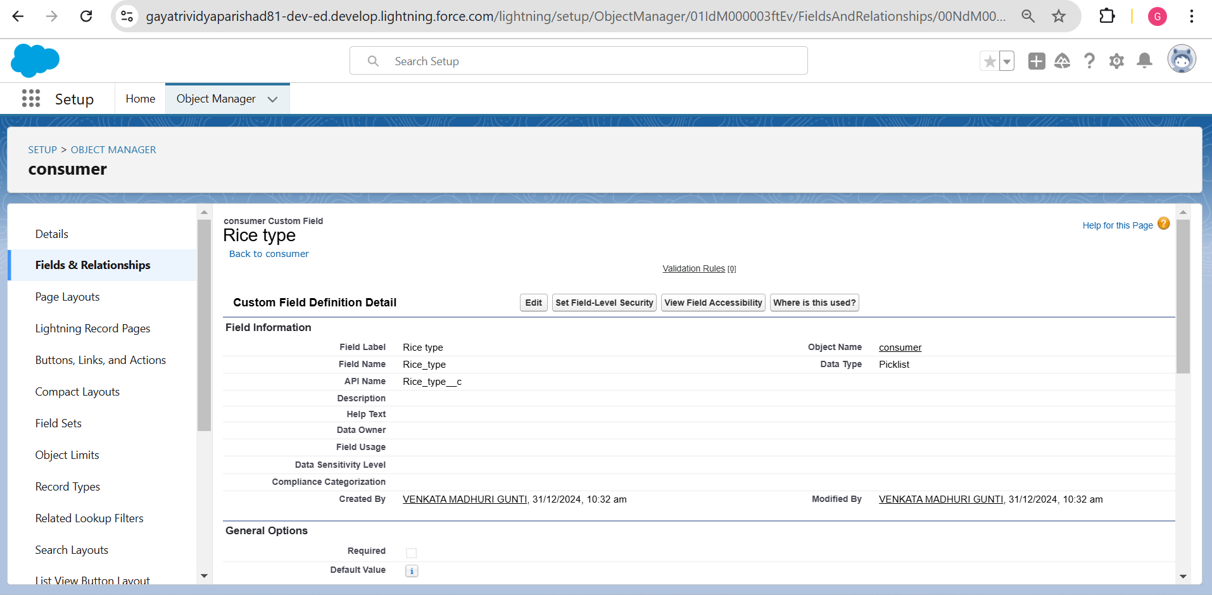

Create New Field For Phone Number:

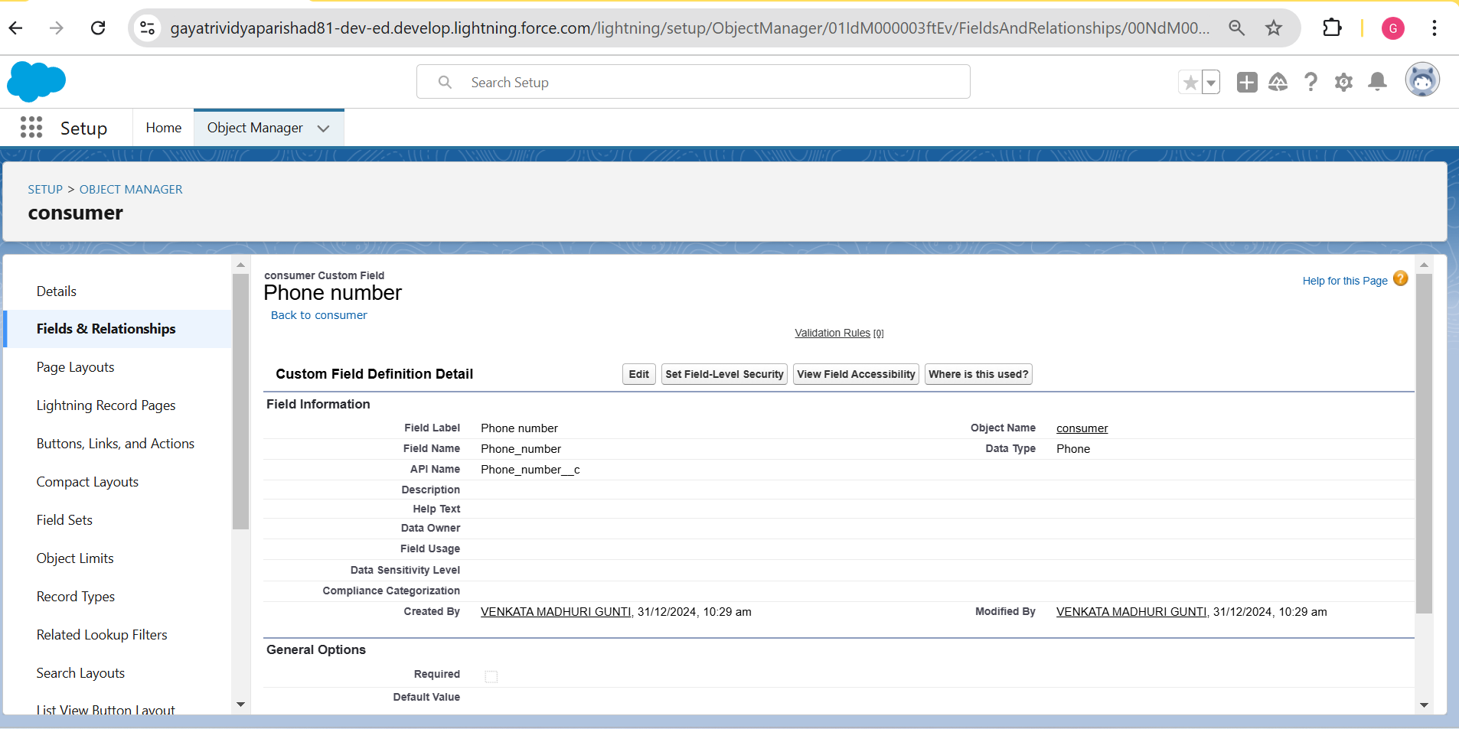

Create New Field For Mode Of Payment:

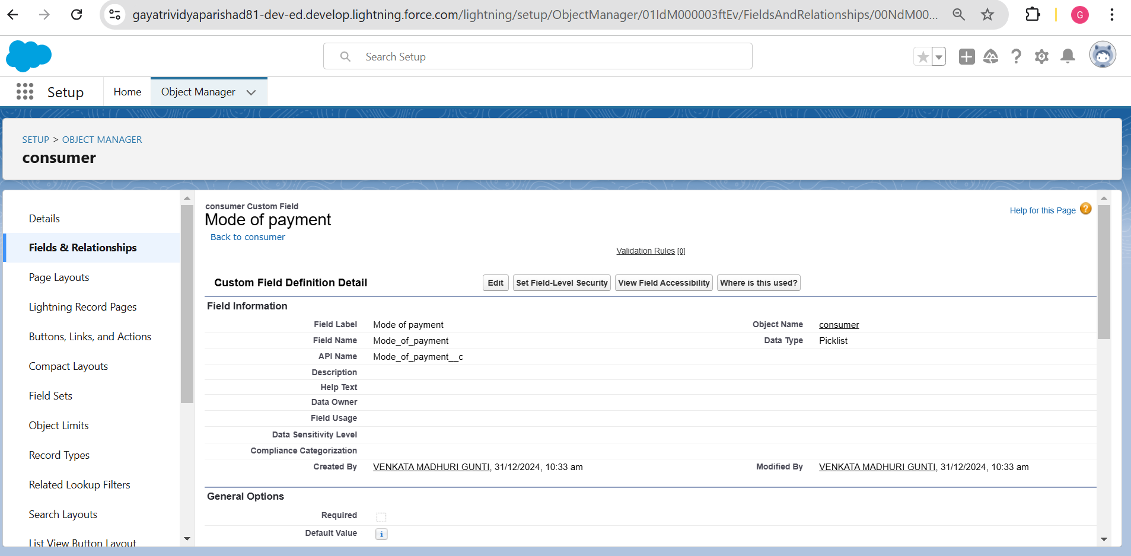

# Activity 8: Creating Cross Object Formula Field in Consumer Object

A cross-object formula field is a formula field that references fields from another object in Salesforce. This type of formula allows users to calculate and display data from multiple objects on a single record.

* Go to setup → click on Object Manager → type object name (consumer) in the search bar Click on Fields & Relationships → click on New.
* Select Data type as “Formula” and click Next.
* Give Field Label and Field Name as “Amount Paid” and select formula return type as “Number” Formula : rice_taken_by_shopsc * rice_mill_namer.rice_price_kgc

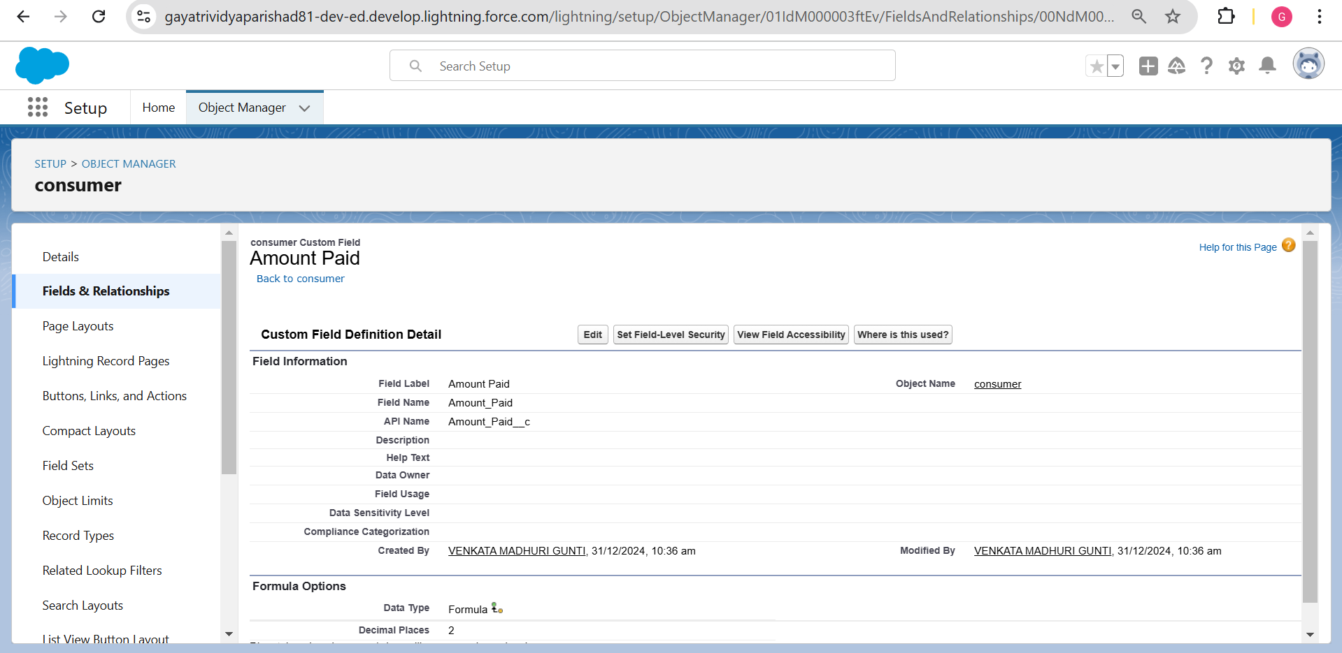

* Give Field Label and Field Name as “Amount Paid” and select formula return type as “Number” and Next.
* Go to setup → click on Object Manager → type object name (consumer) in the search bar
* Click on Fields & Relationships → click on New.
* Select Data type as “Formula” , click Next.
* Give Field Label and Field Name as “Consumer Name” and select formula return type as “TEXT” , click Next.
* Insert field formula should be: First_Namec + ' ' + Last_Namec , Check For syntax.

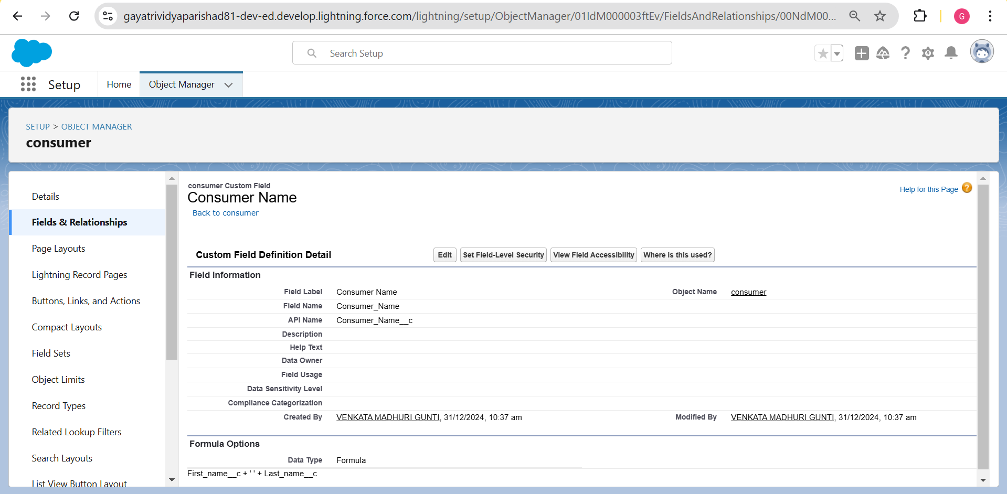

# Activity 9: Creating the Validation Rule

Improve the quality of your data using validation rules. Validation rules verify that the data a user enters in a record meets the standards you specify before the user can save the record. A validation rule can contain a formula or expression that evaluates the data in one or more fields and returns a value of “True” or “False”. Validation rules also include an error message to display to the user when the rule returns a value of “True” due to an invalid value.

Creating the Validation Rule for Phone Number Field in Consumer Object

* + Go to the setup page → click on Object Manager → from the dropdown click edit for the consumer object.
  + Click on Validation Rules → click New.
  + Enter the Rule Name as “Phonenumberoremailblankrule”.
  + Enter the Description as “Phone number and email should not be blank”.
  + Enter the formula as: OR( ISBLANK( phone_numberc ), ISBLANK( emailc )) .
  + Check the syntax.
  + Under the Error Message , Write “Please fill in your Phone Number”.
  + Save Validation rule .

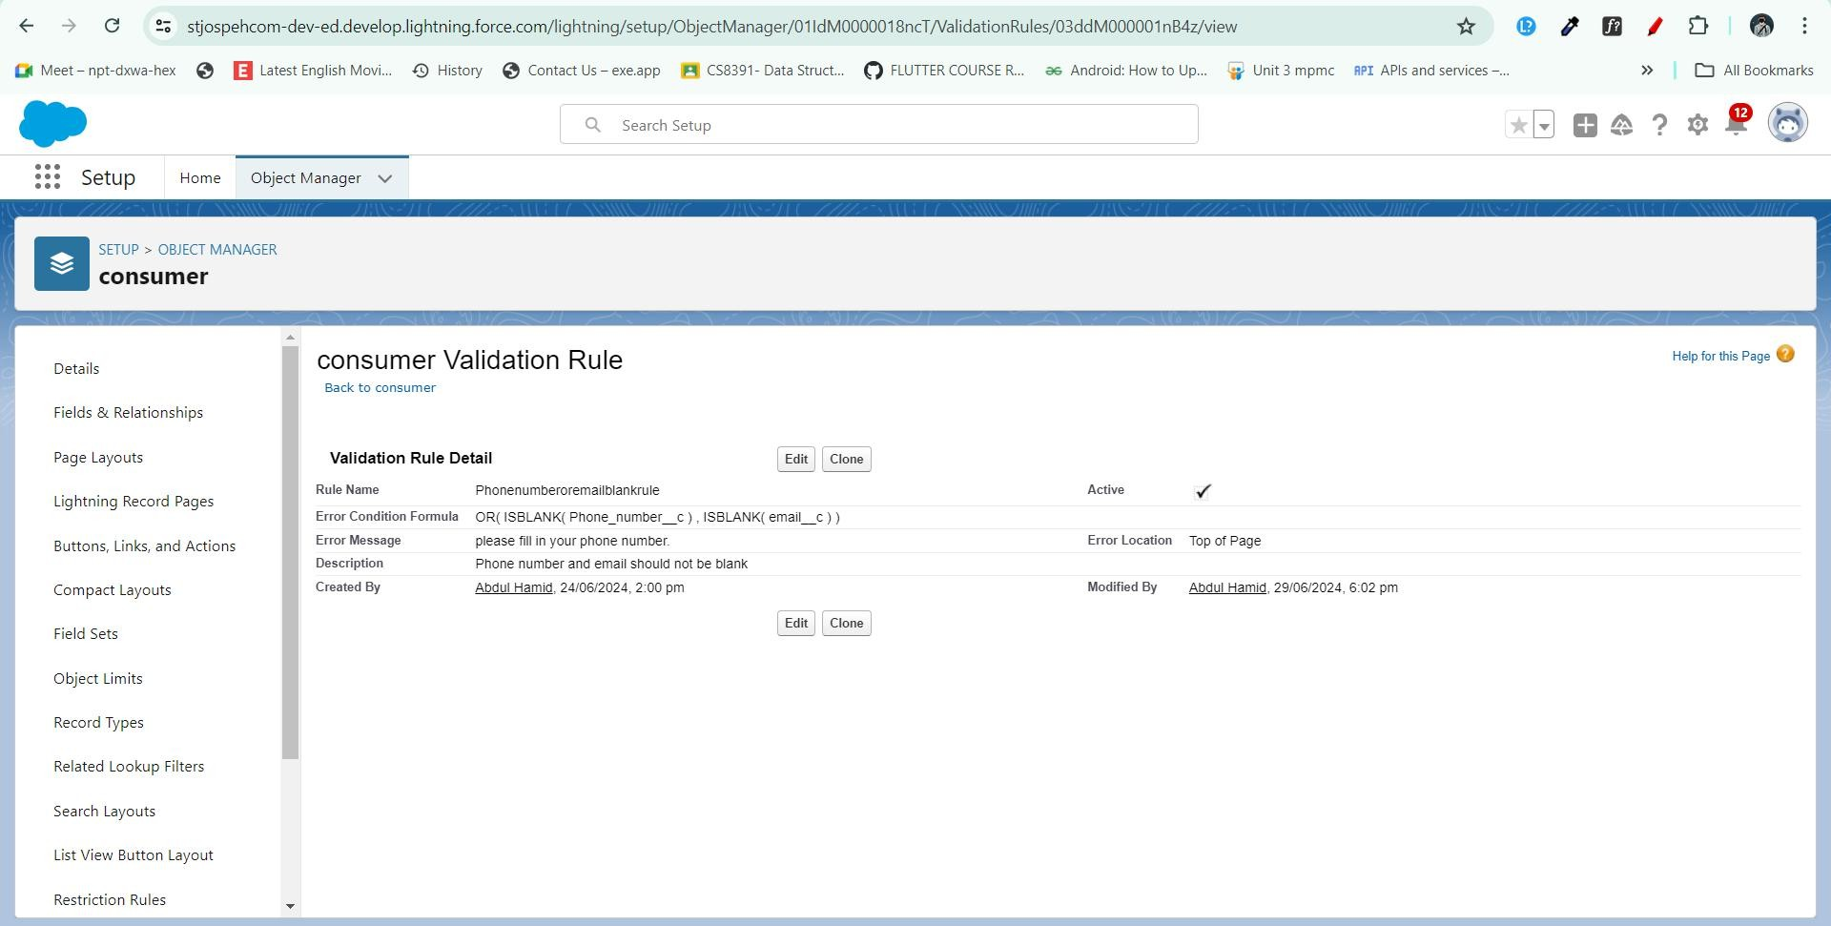

Overall Supplier Fields

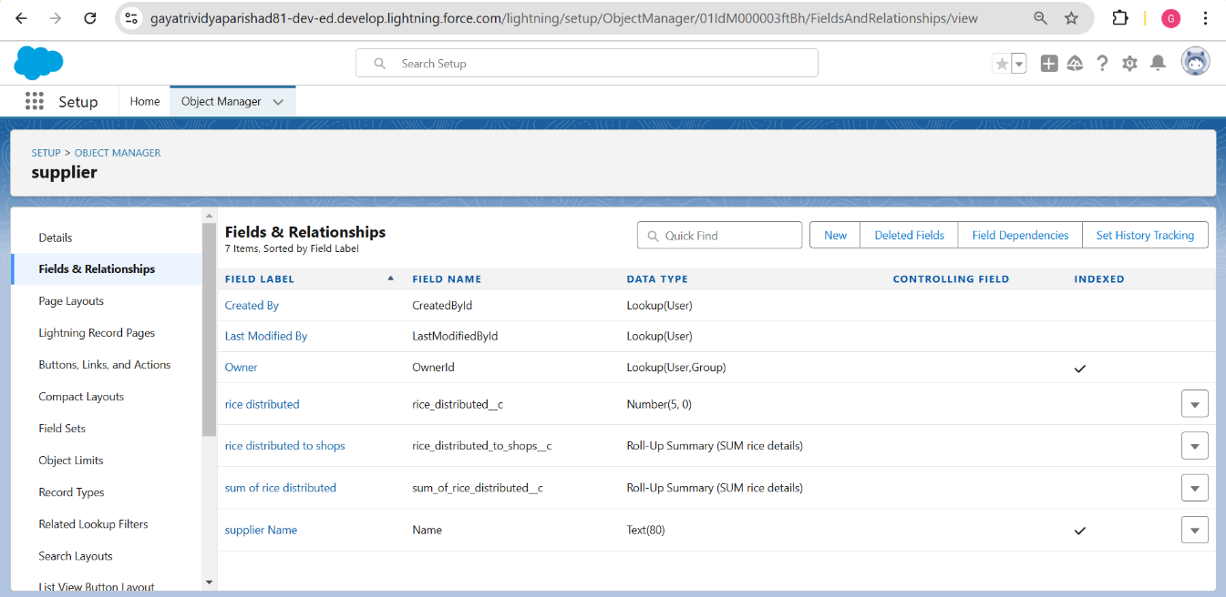

Overall Rice Mills Fields

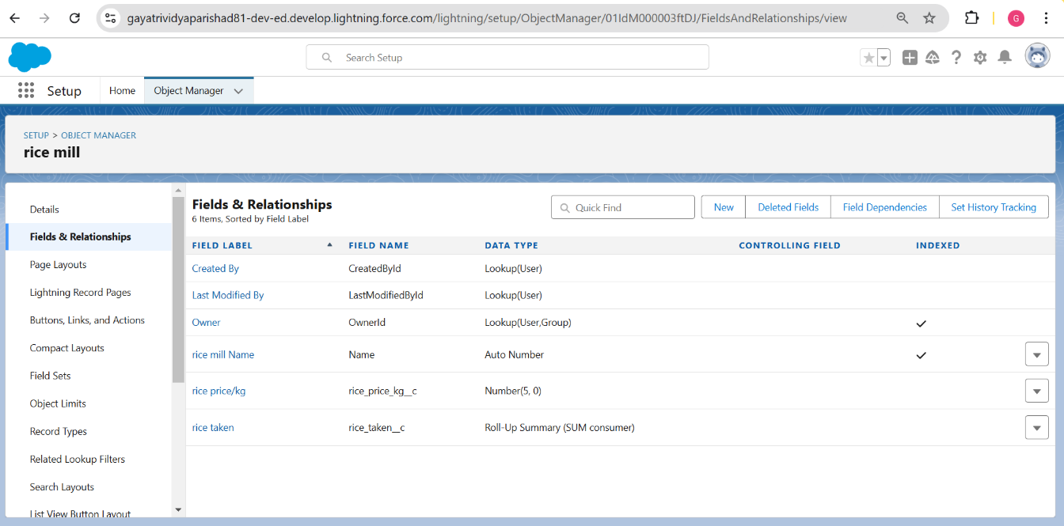

Overall Rice Details Field

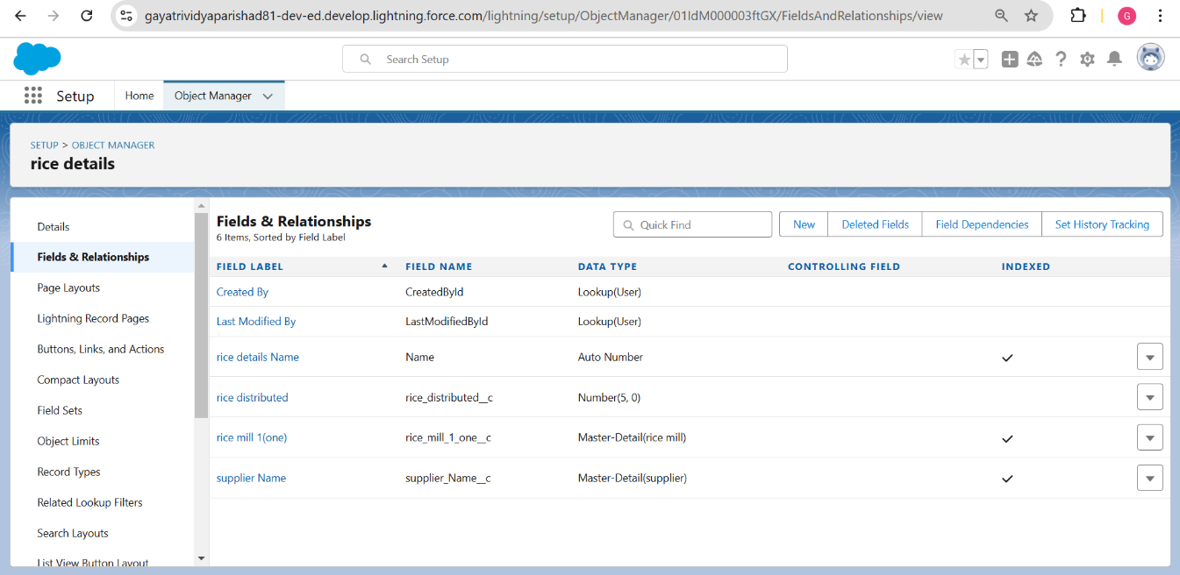

Overall Consumer Fields

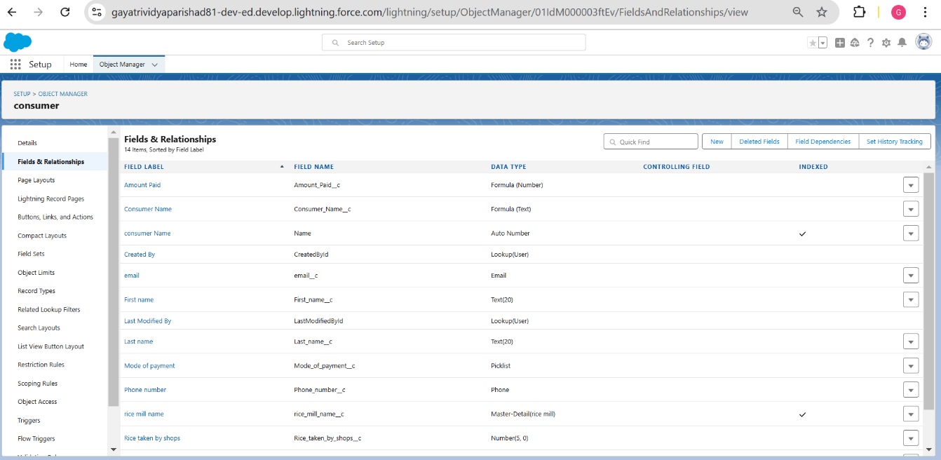

# Milestone 6: Page Layouts

Page Layout in Salesforce allows us to customize the design and organize detail and edit pages of records in Salesforce. Page layouts can be used to control the appearance of fields, related lists, and custom links on standard and custom objects' detail and edit pages.

# Activity 1: Creating the Page Layout

* Go to Setup → Click on Object Manager → Search for the object (consumer) → From the dropdown select the object and click on it.
* Click on Page Layout → Click on New.
* Select the existing page layout, and give the page layout name as “consumer layout”, and click Save.
* Drag and drop the section field to Consumer Details and create the section.
* Enter the section name as “Personal Details”, → click Ok.
* Now drag the fields to this section that are mentioned: First Name , Last Name , Consumer Name , etc.
* Follow the same process for another two sections as shown above. They are:
  + Section: "Rice Details" Fields: Rice Taken by Shop, Rice Type
  + Section: "Receipt Details" Fields: Mode of Payment, Amount Paid
* Click Save.
* 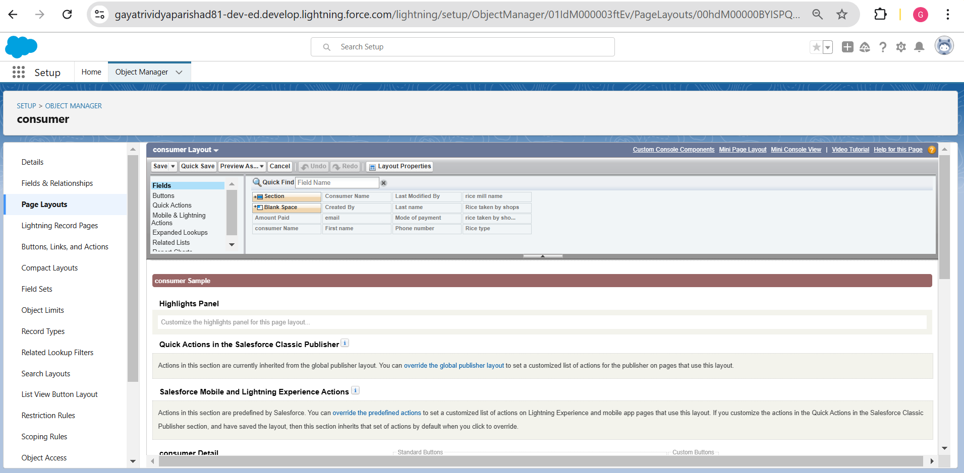

# Milestone 7: Profiles

A profile is a group/collection of settings and permissions that define what a user can do in Salesforce. Profiles control object permissions, field permissions, user permissions, tab settings, app settings, Apex class access, Visualforce page access, page layouts, record types, login hours, and login IP ranges. You can define profiles by the user's job function. For example, System Administrator, Developer, Sales Representative.

Types of Profiles in Salesforce

1. Standard Profiles

By default, Salesforce provides the following standard profiles:

* + Contract Manager
  + Read Only
  + Marketing User
  + Solutions Manager
  + Standard User
  + System Administrator

1. Custom Profiles

Custom profiles are defined by us. They can be deleted if there are no users assigned with that particular profile.

# Activity 1: Owner Profile

To create a new profile:

* Go to Setup → type "Profiles" in the quick find box → click on Profiles → clone the desired profile (Standard User) → enter profile name (Owner) → Save.
* Scroll down to Custom Object Permissions and give access permissions for consumers, rice details, rice mill, and suppliers objects as mentioned in the below diagram.
* Give access and save it.

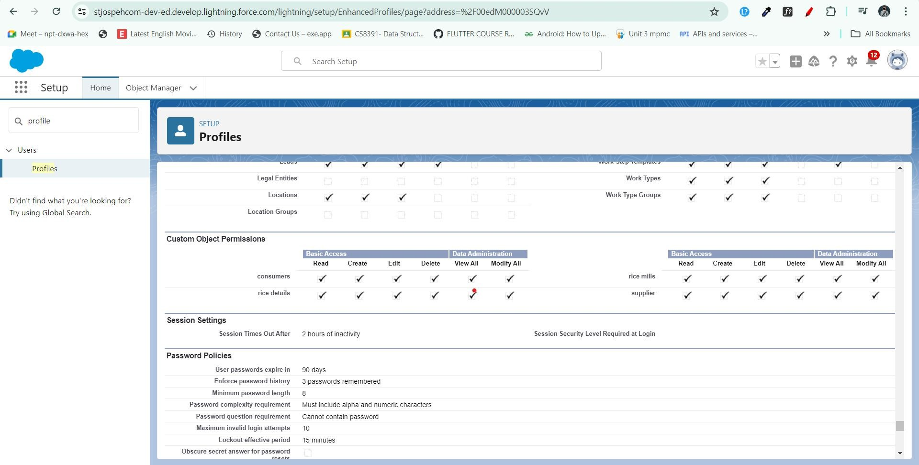

# Activity 2: Employer Profile

To create a new profile:

* Go to Setup → type "Profiles" in the quick find box → click on Profiles → clone the desired profile (Standard Platform User) → enter profile name (Employer) → Save.
* While still on the profile page, click Edit.
* Select the Custom App settings as default for the rice mill.
* Scroll down to Custom Object Permissions and give access permissions for consumer, rice details, rice mill, and suppliers objects as mentioned in the below diagram. Click Save.

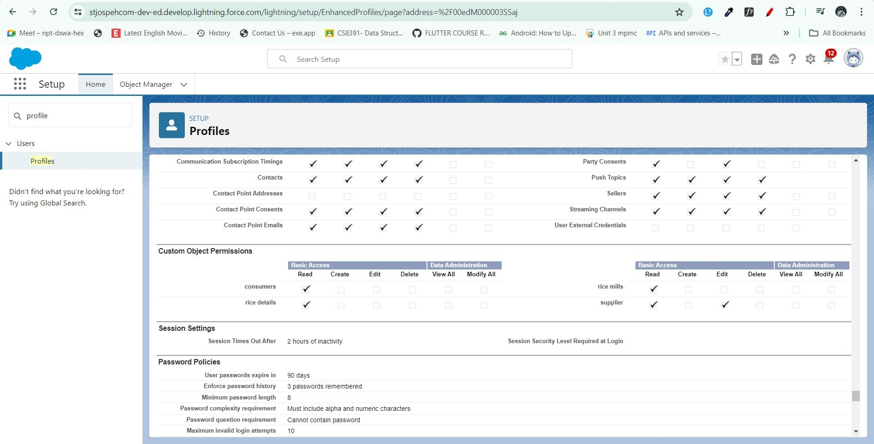

# Activity 3: Workers Profile

To create a new profile:

* Go to Setup → type "Profiles" in the quick find box → click on Profiles → clone the desired profile (Standard Platform User) → enter profile name (Workers ) → Save.
* While still on the profile page, click Edit.
* Select the Custom App settings as default for the rice mill.
* Scroll down to Custom Object Permissions and give access permissions for consumer, rice details, rice mill, and suppliers objects as mentioned in the below diagram. Click Save.

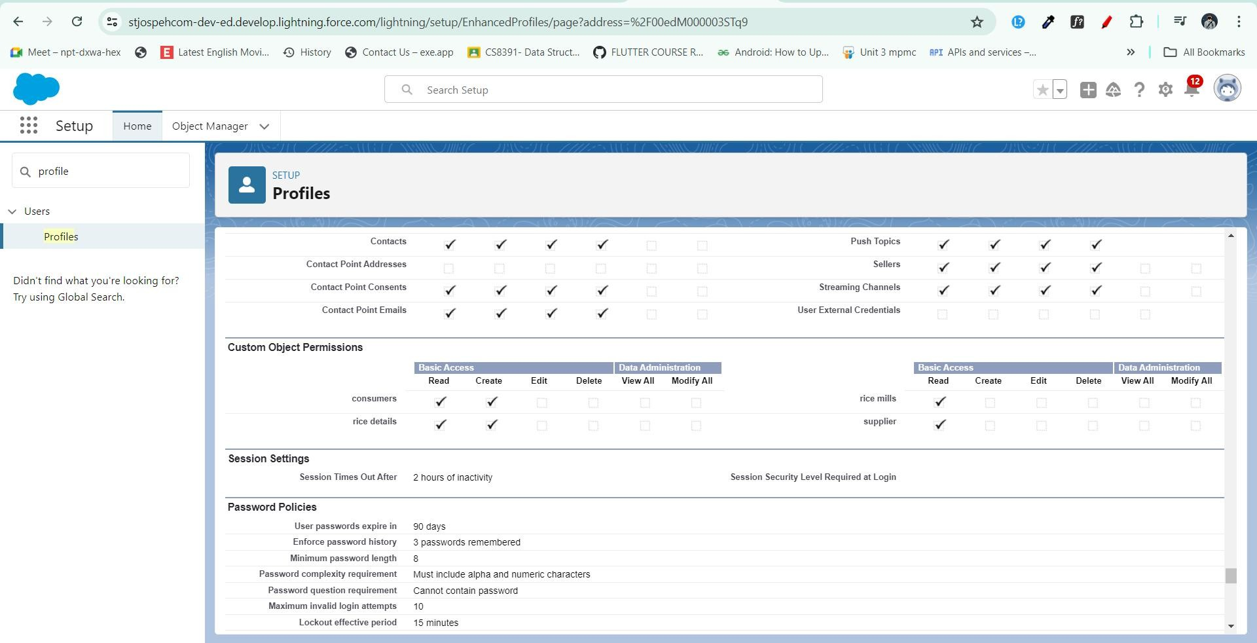

# Milestone 8: Role & Role Hierarchy

A role in Salesforce defines a user's visibility access at the record level. Roles may be used to specify the types of access that people in your Salesforce organization can have to data. Simply put, it describes what a user could see within the Salesforce organization.

# Activity 1: Creating Owner Role

Creating Owner Role:

* Go to Quick Find → search for Roles → click on Set Up Roles.
* Click on Expand All and click on Add Role under whom this role works.
* Give Label as “Owner” and Role Name gets auto-populated. Then click on Save.
* Click and save it.

# Activity 2: Creating Employer Roles

Creating Another Two Roles Under Manager:

* Go to Quick Find → search for Roles → click on Set Up Roles.
* Click the plus on CEO role, and click Add Role under Owner.
* Give Label as “Employer” and Role Name gets auto-populated. Then click on Save.
* Repeat the same steps for another role.
* Click the plus on CEO role, and click the plus on Owner, and click Add Role under Employer.
* Give Label as “Worker” and Role Name gets auto-populated. Then click on Save.

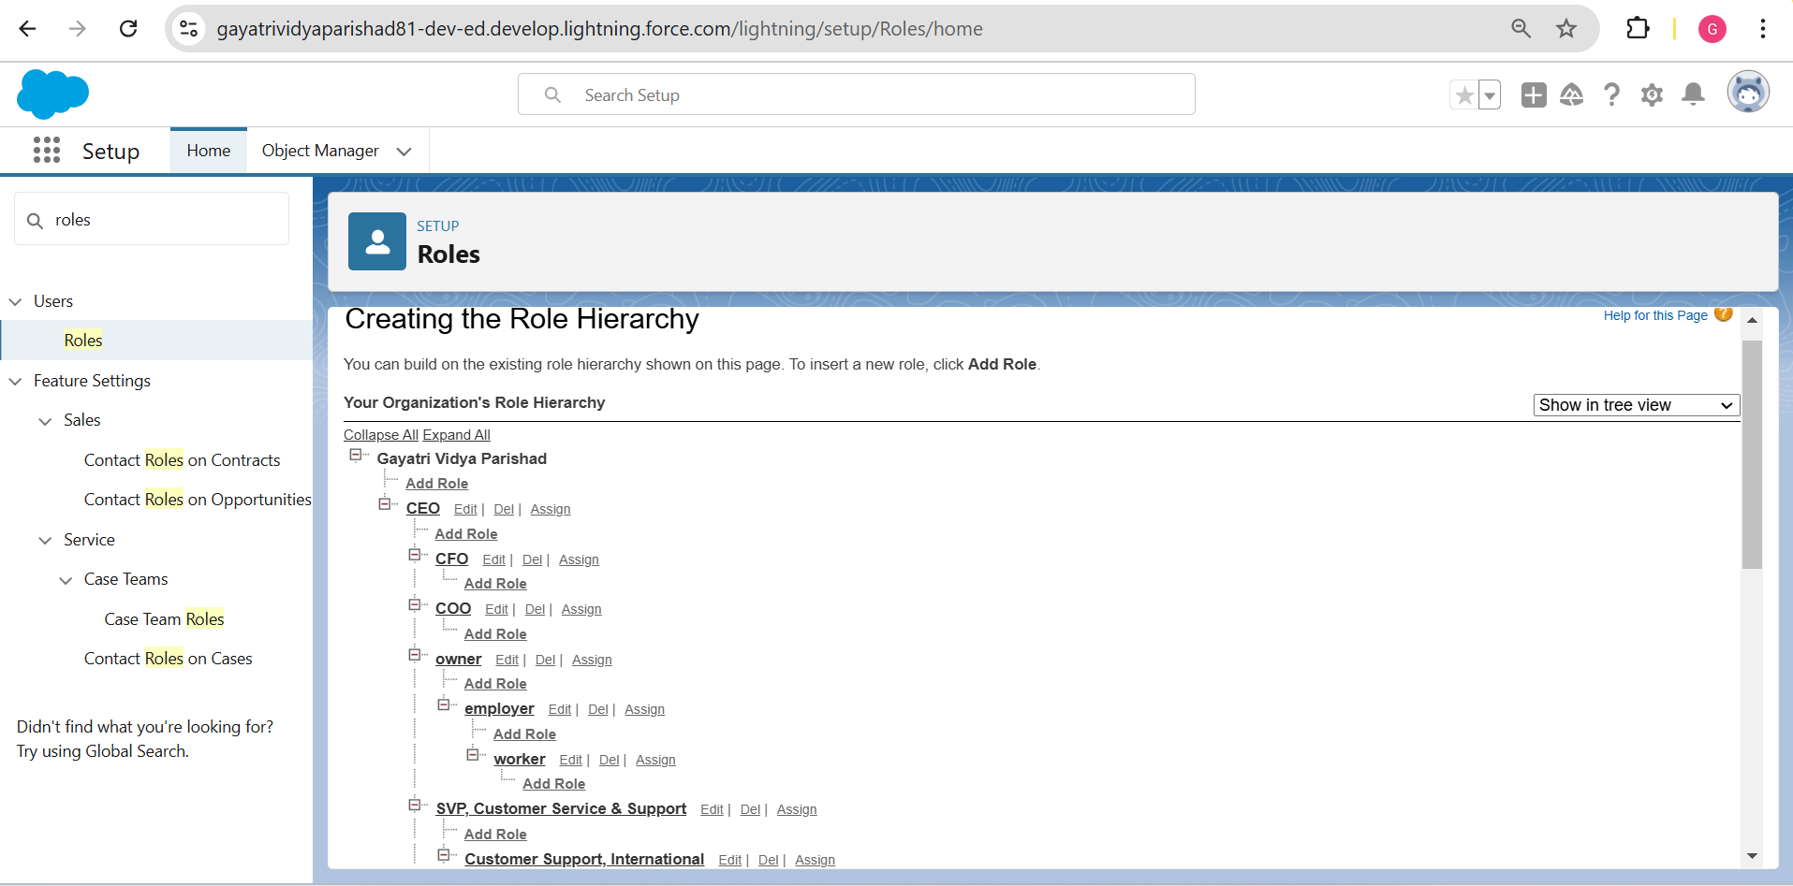

# Milestone 9: Users

A user is anyone who logs in to Salesforce. Users are employees at your company, such as sales reps, managers, and IT specialists, who need access to the company's records. Every user in Salesforce has a user account. The user account identifies the user, and the user account settings determine what features and records the user can access.

# Activity 1: Create User

* + Go to Setup → type "Users" in the quick find box → select Users → click New User.
  + Fill in the fields:
    - First Name: Vicky
    - Last Name: Y
    - Alias: Vy
    - Email ID: [abdulhamid282002@gmail.com](mailto:abdulhamid282002@gmail.com)
    - Username: [abdul@abdul.abdul](mailto:abdul@abdul.abdul)
    - Nickname: Vicky
    - Role: Owner
    - User License: Salesforce
    - Profile: Owner
    - Save it.

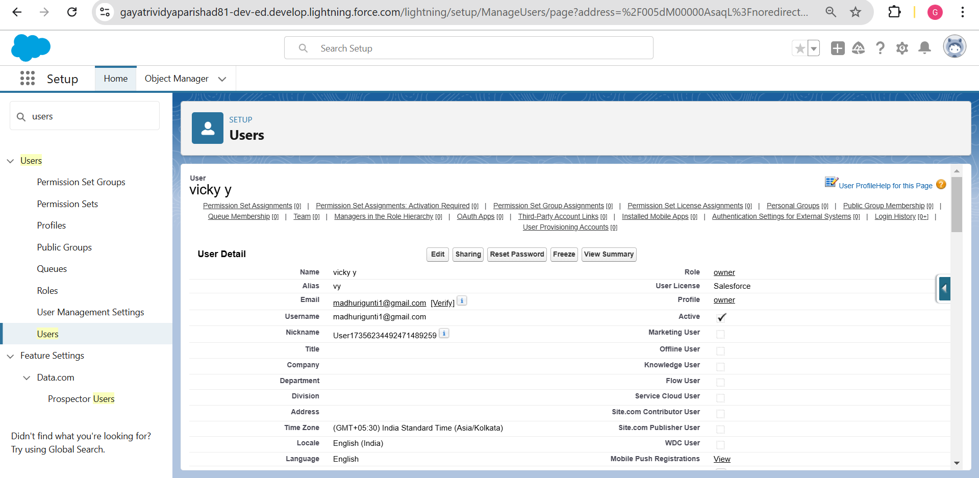

# Activity 2: Creating Another Users

* Go to Setup → type "Users" in the quick find box → select Users → click New User.
* Fill in the fields:
  + First Name: ram
  + Last Name: ram
  + Alias: rram
  + Email ID: [abdulhamid282002@gmail.com](mailto:abdulhamid282002@gmail.com)
  + Username: [rama@rama.rama](mailto:rama@rama.rama)
  + Nickname: ram
  + Role: Employer
  + User License: Salesforce Platform
  + Profile: Standard Platform User
  + Save it.

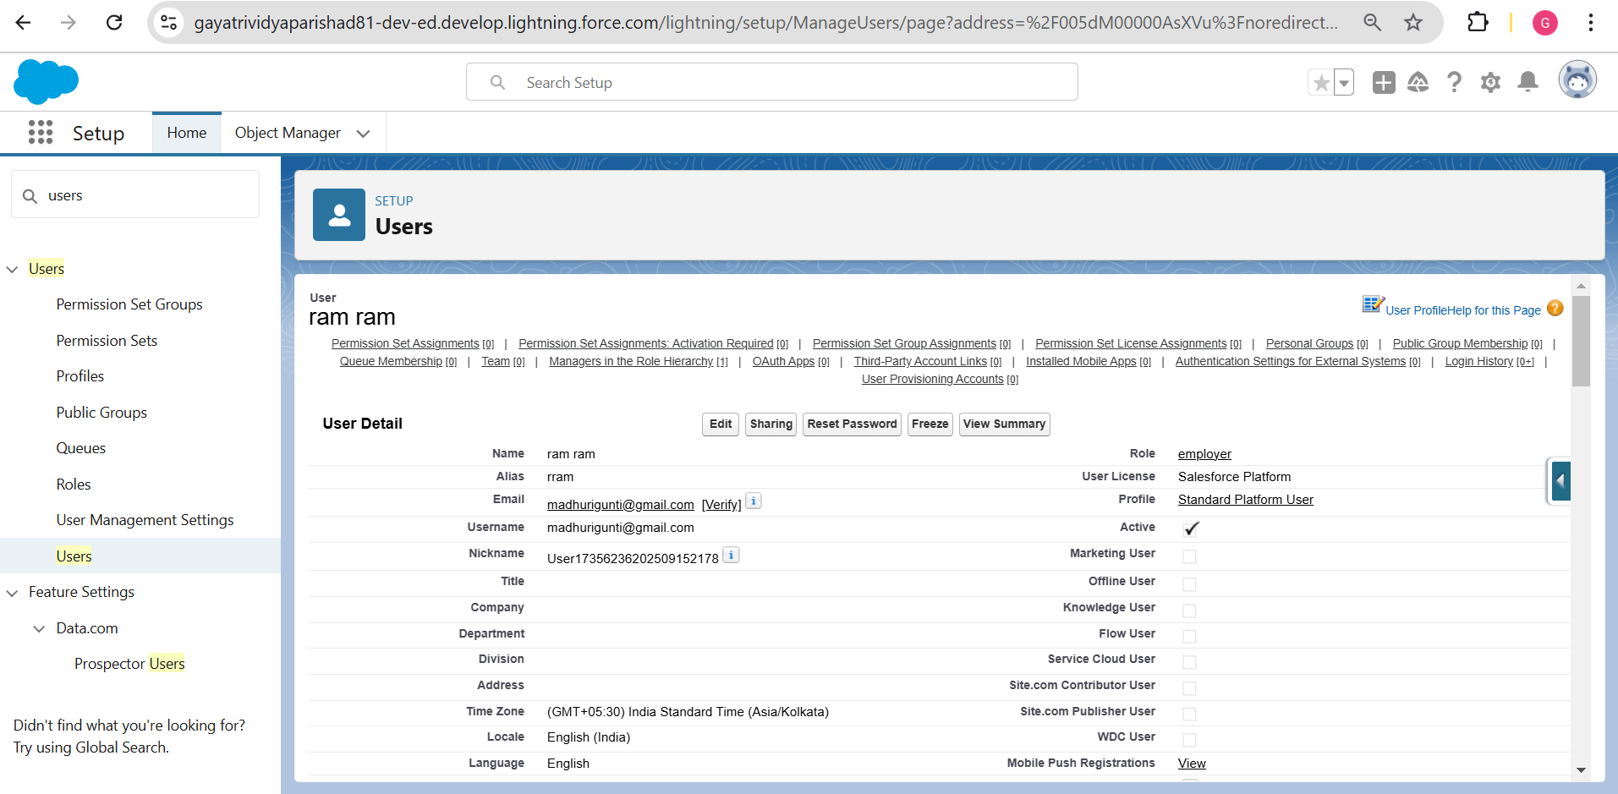

* Go to Setup → type "Users" in the quick find box → select Users → click New User.
* Fill in the fields:
  + First Name: ragu
  + Last Name: raj
  + Alias: rraj
  + Email ID: [abdulhamid2822002@gmail.com](mailto:abdulhamid2822002@gmail.com)
  + Username: [ragun@ragun.ragun](mailto:ragun@ragun.ragun)
  + Nickname: ragu
  + Role: Worker
  + User License: Salesforce Platform
  + Profile: Standard Platform User
  + Save it.

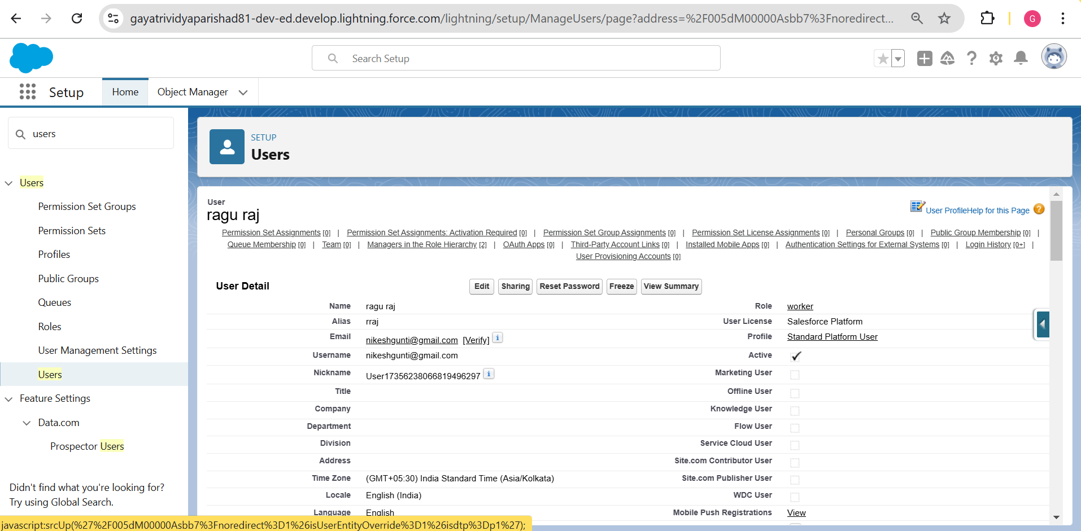

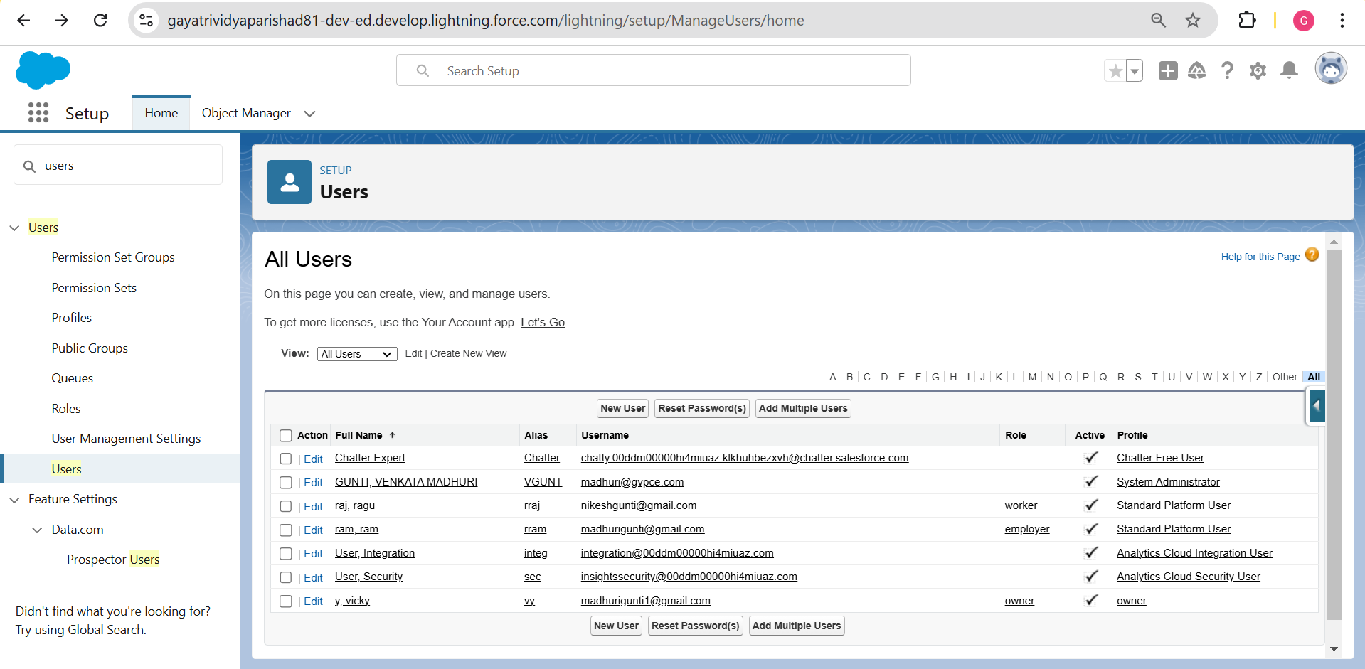

# Milestone 10: Permission Sets

A permission set is a collection of settings and permissions that give users access to various tools and functions. Permission sets extend users’ functional access without changing their profiles and are the recommended way to manage your users’ permissions.

# Activity 1: Creating OWD Setting

* Go to Setup → type “Sharing Settings” in quick search → Click Edit.
* Scroll down, change the default internal access to “Public Read-Only” for Rice Mill and Supplier objects.
* Click Save.

Extra Information:

By setting the Organization-Wide Defaults (OWD) to "Public Read-Only," every profile has its own access according to their profile. In our case, roles are created and assigned so that the owner can see employer and worker records, and the employer can see worker records.

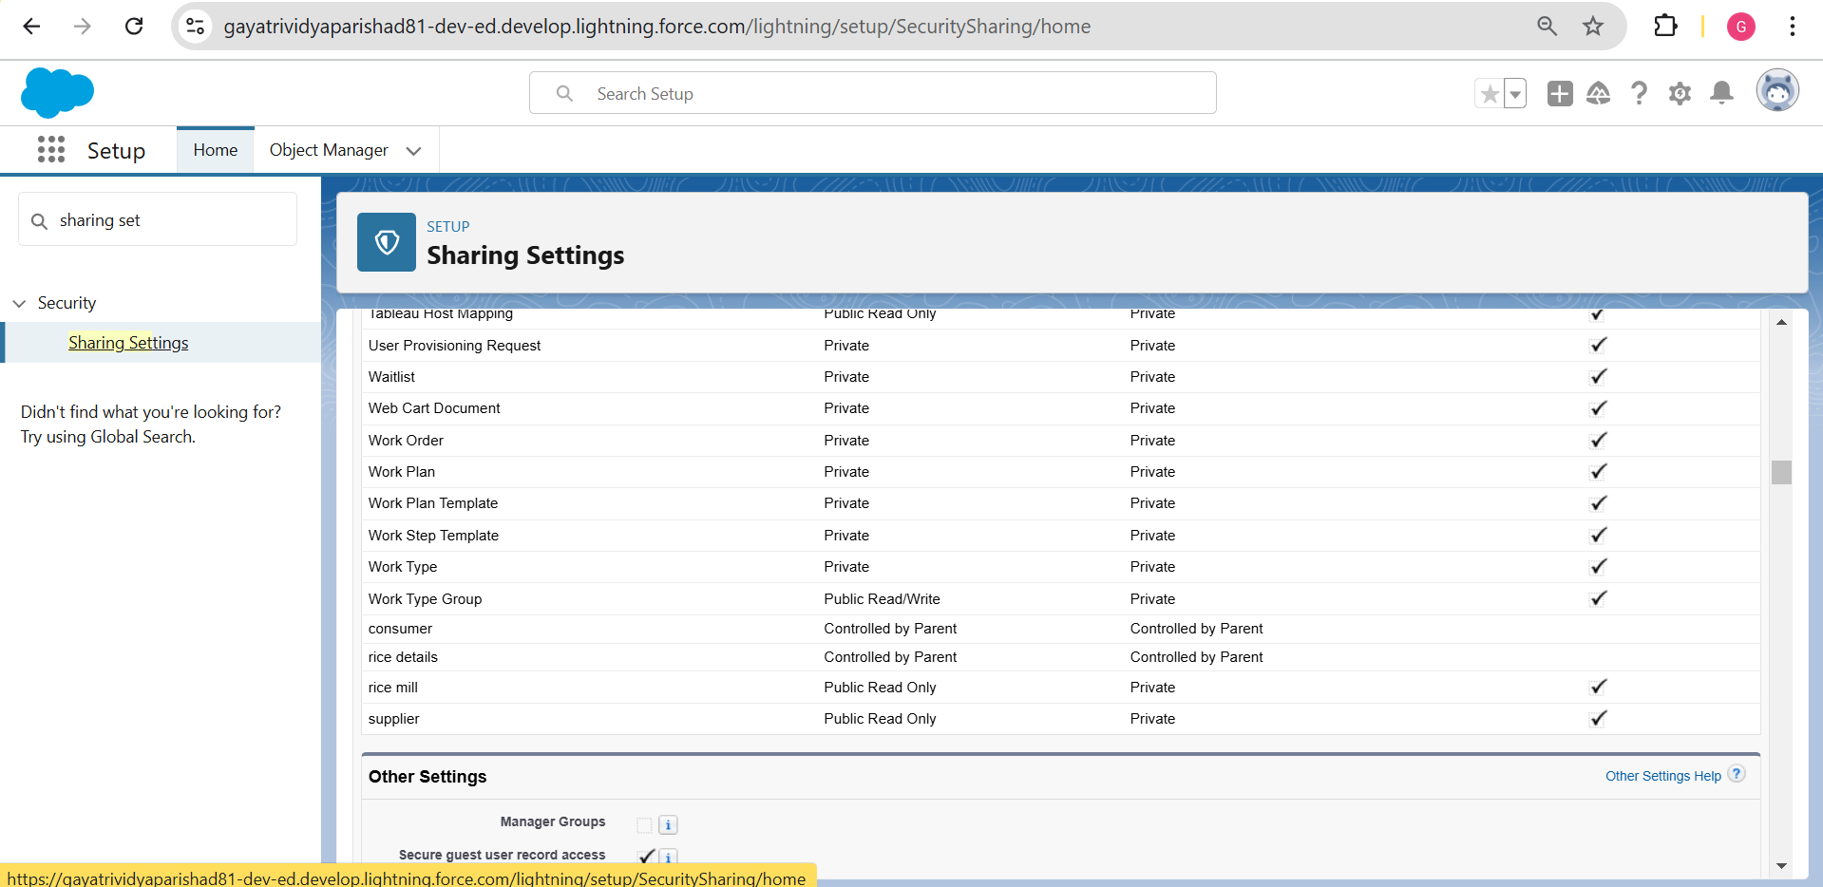

# Milestone 11: Reports

Reports give you access to your Salesforce data. You can examine your Salesforce data in almost infinite combinations, display it in easy-to-understand formats, and share the resulting insights with others. Before building, reading, and sharing reports, review these reporting basics. Salesforce.com provides a powerful suite of analytic tools to help you organize, view, and analyze your data.

# Activity 1: Create Report

* Go to the app → click on the Reports tab.
* Click New Report.
* Select for Report Type, search for “Rice Mill with Consumers”, click on it, and click Start Report.
* The outline pane is opened already, select the fields that are mentioned below in the Column section:
  + Consumer Name
  + Rice Type
  + Rice Price/kg
  + Mode of Payment
  + Amount Paid
* Remove the unnecessary fields.
* Select the field that is mentioned below in the Group Rows section:
  + Rice Taken by Shops
* Click Save and Run .
* Save the report as “Range of Amount per Day”.
* Save it.

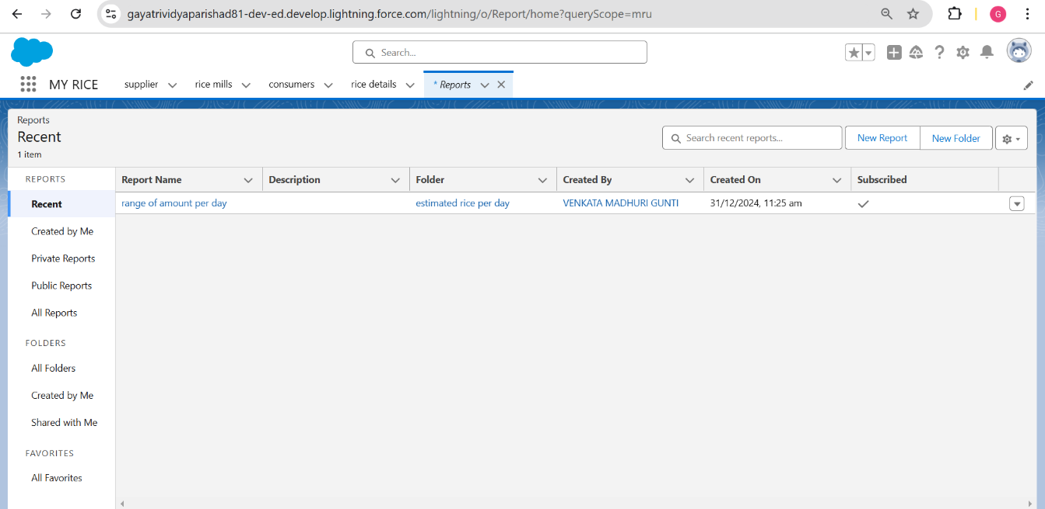

# Activity 2: Sharing Report to Owner

* Click on the report to open it.
* Click the Edit dropdown menu and select the Subscribe option.
* After selecting to run the report as "Another Person," select your personal account or the person you want to send the email to.
* Click Save.
* Note: The owner gets a daily email notification of the Rice Mill report so that they can see all data remotely.

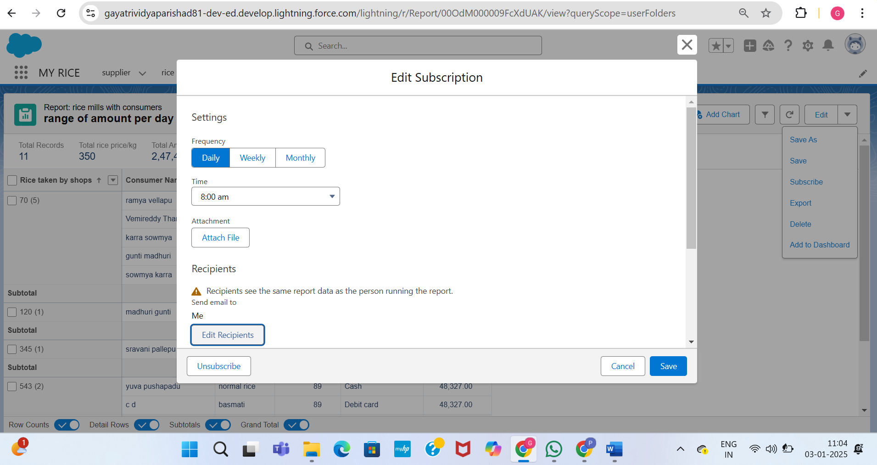

# Activity 3: Create a Report Folder

Steps to Create a Report Folder:

* + Click on the App Launcher and search for "Reports".
  + Double-click on "Reports". The "Reports tab" will be auto-populated in the navigation bar.
  + Click on the "Reports" tab, then click on New Folder.
  + Give the Folder Label as “Estimated Rice per Day”. The Folder Unique Name will be auto-populated.
  + Click Save.

Moving a Report to the New Folder:

* + Navigate to the App Launcher and click on Reports.
  + Click All Reports.
  + Select the "Range of Amount per Day" report from the dropdown menu.
  + Click Move.
  + Select the "Estimated Rice per Day" folder and click Select.

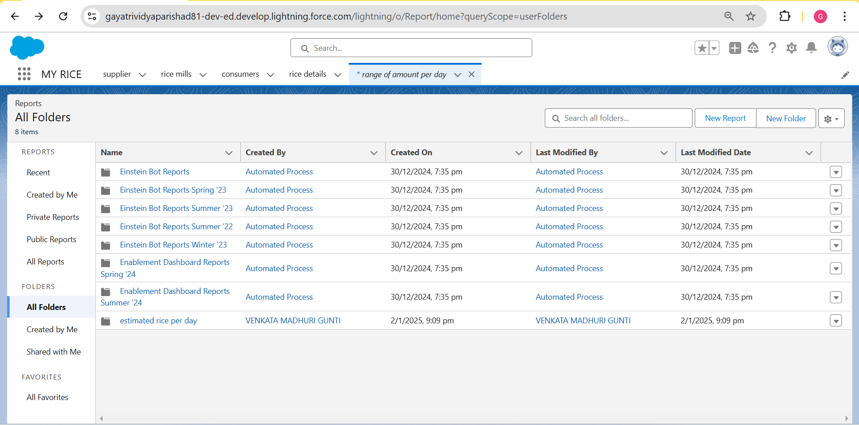

Overall Reports (Range of amount per day)

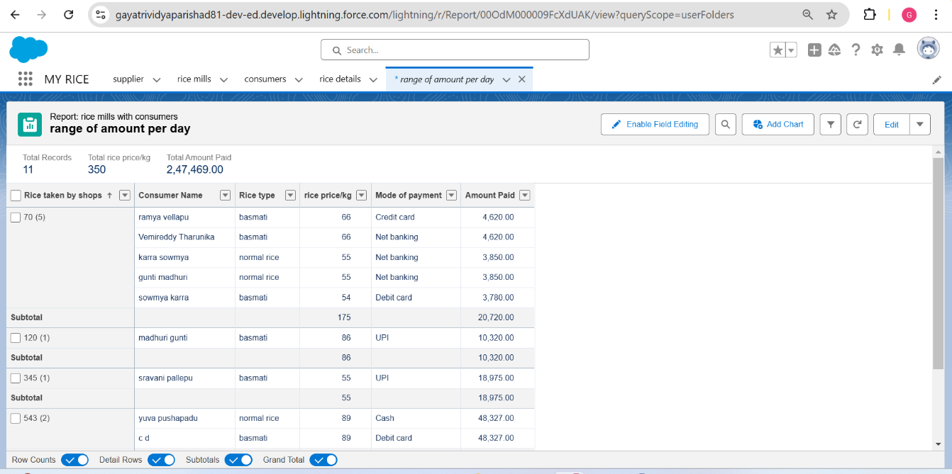

# Milestone 12: Dashboards

Dashboards help you visually understand changing business conditions so you can make decisions based on the real-time data you’ve gathered with reports. Use dashboards to help users identify trends, sort out quantities, and measure the impact of their activities. Before building, reading, and sharing dashboards, review these dashboard basics.

# Activity 1: Create Dashboard Folder

Steps to Create a Dashboard Folder:

* + Click on the App Launcher and search for "Dashboard".
  + Click on the Dashboard tab.
  + Click New Folder.
  + Give the Folder Label as “Amount Data Dashboard”.
  + Folder Unique Name will be auto-populated.
  + Click Save.

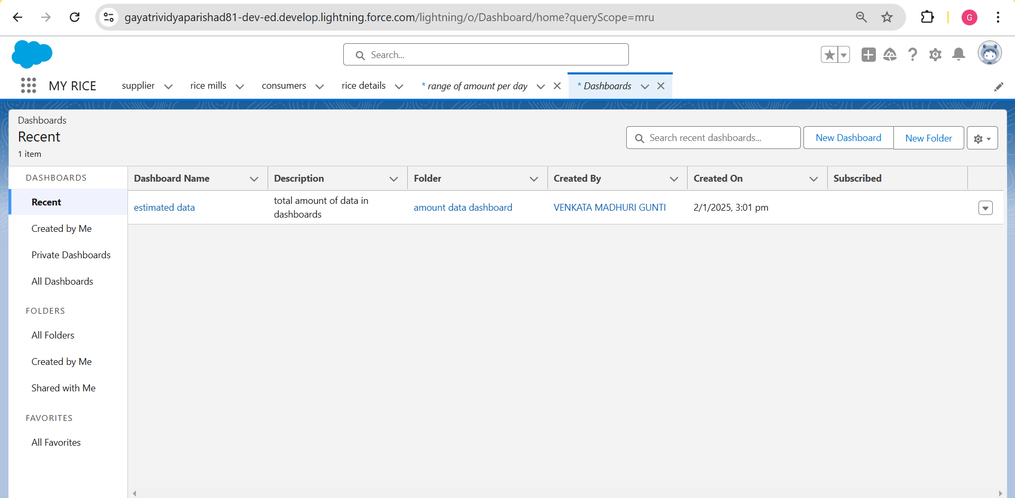

# Activity 2: Create Dashboard

* + Go to the App → click on the Dashboards tab.
  + Give a Name and select the folder that was created, and click Create.
  + Select Add Component.
  + Select a Report and click Select.

First Component Details:

* + Display as: Vertical Bar Chart
  + X-axis: Rice Taken by Shops
  + Y-axis: Sum of Amount
  + Y-axis Range: Automatic
  + Sort by: Rice Taken by Shops
  + Component Theme: Dark

Second Component Details:

* + Select Add Component with the same steps as above.
  + Display as: Donut Chart
  + Sort by: Sum of Amount
  + Title: Range of Amount per Day
  + Component Theme: Dark

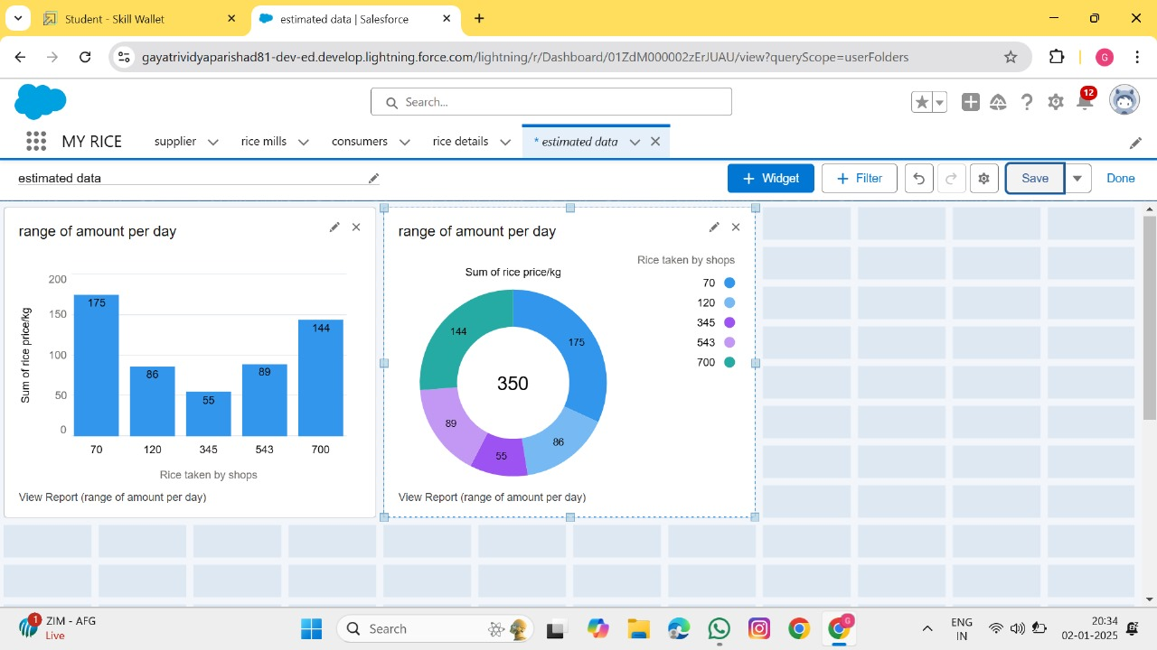

Milestone 13: APEX

Activity 1: **Creating an Apex Class(ConsumerRecord)**

1. Login to the Salesforce account and navigate to the gear account in the top right corner.
2. Then we can see the Developer console. Click on the developer console and you will navigate to a new console window.
3. Then you can see many tools in the Toolbar of the new console window. Click on File, New and Apex Class.
4. Enter the name of the class(ConsumerRecord) to create a new class file.

**Code Snippet :**

class ConsumerRecord {

    public static void sendEmailNotification (List<consumer__c> con){

        for(consumer__c c:con)

        {

            Messaging.SingleEmailMessage email = new Messaging.SingleEmailMessage();

                email.setToAddresses( new List<String>{c.email__c});

                email.setSubject('Welcome to our company');

                email.setPlainTextBody('Dear '  + ' '+ ',\n\nWelcome to MY RICE!'+'You have been seen as a valuable customer to us. PLease continue your journey with us, while we try to provide you with good quality resources.'+'\n'+

                                           "We are proud to associate with valuable customers like you and we look forward to collaborating with you by providing more and more exciting discounts or even product offers too.' + '\n'

                                           +'So why taking a step back, take a leap of faith and shop with us more, while we provide with the valuable products and offers'+'\n'+'\n'+'\n'+

                                           'Thankyou for buying '+ '' +'Here are some of the products that are brought by the customers who similarly bought products like this'+'\n\n');

                Messaging.sendEmail(new List<Messaging.SingleEmailMessage>{email});

        }

    }

}

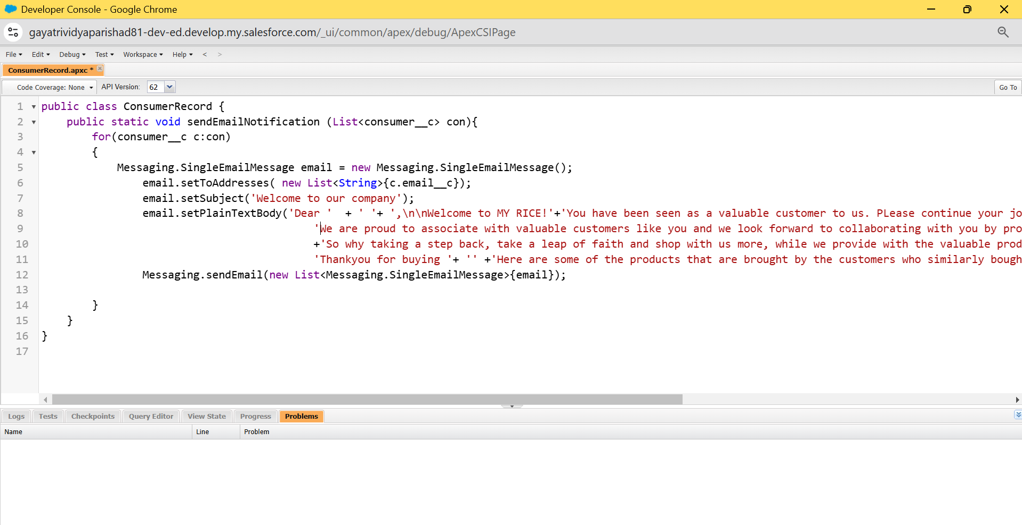

Activity 2: **Creating an Apex Trigger**

**How to create a new trigger :**

While still in the trailhead account, navigate to the gear icon in the top right corner.

Click on developer console and you will be navigated to a new console window.

Click on the File menu in the toolbar, and click on new? Trigger.

Enter the trigger name and the object to be triggered.

**Syntax For creating trigger :**

The syntax for creating trigger is :

Trigger [trigger name] on [object name]( Before/After event) {  
             //Trigger Logic

}

**Trigger code:**

trigger consumerTrigger on consumer__c (After insert) {

    if(trigger.isAfter && trigger.isInsert) {

        ConsumerRecord.sendEmailNotification(trigger.new);

    }

}

